1. **Title Page** *- Adventure Time(Billy’s way)*
   1. Game Name – **″Adventure Time ″ →(Billy’s way)←**
2. **Game Overview**
   1. Game concept

The game looks like a typical 3D first person game. You play as Finn, a 12-year-old boy that wants to meet Billy, the well-known hero of all the realms of the world of U. In order to prove Billy that he is worthy of following in his footsteps, Finn needs to find all the pages of the Enchiridion, the book of all heroes.

After every main quest, Finn finds a page. The game ends when all lost pages are acquired. As the games has 5 main quests, there are a total of 5 lost pages.

Every time when Finn has difficulties solving a problem, he can ask his brother Jake. Jake is sleeping in one of Finns pockets, so he can be bothered any time, but we won’t be happy about it.

* 1. Genre

-RPG, adventure game

* 1. Target Audience

1. Gender: All genders  
2. Age: 10-14 years  
3. Likes games  
4. Likes animated series

* 1. Game Flow Summary

***(2D part)*** The playable character moves in a 2D side scrolling plane, either from left or right, or from right to left. The PC can jump either straight or in a parabola going left or right. When an obstacle is in front of the player you can’t procced any further in that direction.

You are able to attack enemies with your sword ability to cut the air and slash your opponents from a certain fixed range. When a character receives damage, its shade changes to a darker one.

When you enter a new realm you receive a potion that gives you a buff to fight the enemies in that specific region. When you drink the potion the buff is added to your health bar.

***(3D part)*** All the parts of the game, including fights are in FPS. The playable character can move in either direction. The PC can jump either straight or in a parabola going in any direction. When an obstacle is in front of the player you can’t procced any further in that direction.

* 1. Look and Feel

The game will look like a cartoon as the idea is based on the animated TV series, Adventure Time. The characters and the world will have a subtle childish look, as the game is intended for kids with age around 10 to 14. Even if the main quests are created around the idea of the main hero fighting bad creatures and people, the all-around feel of the game must be pleasant, childish, but nimble and captivating, as the challenges become harder and harder with every passed quest.

1. **Gameplay and Mechanics**
   1. Gameplay
      1. Game progression

The game is structured in 5 levels, each level representing a different part of the world. Every realm has its own main quest, and after completing each level you acquire one of the lost pages of the Enchiridion. The game starts at the tree house, and you go through the levels in a linear way. You can’t skip any realm. You reach the end of the game when all the main quests are completed.

After each quest, the main character increases its level, changing all the stats (health, damage, agility, weapon strength).

* + 1. Mission/challenge

Every realm has its own main mission.

1. The home base of the character – Sets the player on a heartwarming adventure to find Tree Trunks and persuade her to bake a delicious apple pie for their loyal companion, Jake. Through a series of objectives and sub-objectives, the player will engage in interactions, problem-solving, and teamwork to achieve the ultimate goal.
2. The realm of ice – The player in an adventure to address Ice King's shady misbehavior and protect Princess Bubblegum. With the guidance of Peppermint Butler and the provided magical buff, the player engages in a challenging battle while navigating the icy terrain of the Ice Kingdom.
3. The realm of slime - Immerses the player in a gooey and vibrant adventure within the Slime Kingdom. By aiding the royal subject in recovering the lost gemstone, the player encounters unique challenges, gets a powerful potion and is rewarded with a crucial page of the Enchiridion.
4. The realm of fire – Plunges the player into the fiery depths of the Fire Kingdom to confront a formidable adversary. With Flambo's assistance and the provided magical buff, the player engages in a challenging battle while navigating the scorching terrain. The quest culminates in the imprisonment of the bad father, ensuring the safety of the Fire Kingdom and its inhabitants.
5. The realm of gum - Takes the player on a sweet and bouncy adventure through the Gum Kingdom. By seeking help from the Princess of Gum, you embark on a quest to find the final Enchiridion page, aided by the realm's unique potion buff. The successful completion of this quest brings you one step closer to meeting your hero, Billy.
   * 1. Objectives

There are only main quests in this game as described before. There is no need for any side quest for the story to progress further.

* + 1. Play Flow

The main character is already defined so there is no character customization.

When the game starts, the main menu is displayed. The options of this menu are: Start game, Settings, Quit game. When you start a new play through, the player is set in the first realm, in the Tree house of Finn and Jake. You can pause the game by pressing ESC and the pause menu will be displayed. This menu has the following options: Resume game, Settings, Quit to Desktop. When you travel between worlds, a loading screen is displayed.

* 1. Mechanics
     1. Physics

The movement and physics of a character are governed by a combination of algorithms and simulations designed to create a realistic or stylized interactive experience. Here are some key aspects to consider:

**2D prototype**

1. **Position and Orientation:**

The character's position is represented by a set of coordinates (x, y) on a 2D plane.

1. **Controls:**

Player input from a keyboard, joystick, or other input device is processed by the game engine. For example, pressing the right arrow key might translate to rightward movement.

1. **Translation:**

Movement is implemented using translation along the x and y axes. The character's position is updated based on the direction and magnitude of the input.

1. **Collision Detection:**

The game engine checks for collisions between the character and other objects or surfaces in the environment. This is crucial for preventing characters from passing through walls or falling through the ground.

1. **Gravity:**

Gravity is a downward force applied to the character, affecting jumping and falling. When the character is not grounded, gravity accelerates its downward motion.

1. **Jumping and Platforming:**

Jumping involves applying an upward force to the character. The duration and strength of the jump can be affected by factors like how long the jump button is held down.

1. **Friction:**

Friction can be applied to the character's movement, affecting how quickly it comes to a stop when no input is given.

1. **Velocity and Acceleration:**

The character's movement can be affected by velocity (speed and direction) and acceleration (how quickly the character changes speed).

1. **Camera Movement:**

The camera follows the character horizontally, giving the player a view of the current portion of the level.

**3D game**

1. **Position and Orientation:**

The character's position in the game world is represented by a set of coordinates (x, y, z) that determine its location in three-dimensional space.

Orientation is represented by a combination of angles (yaw, pitch, roll) which determine which way the character is facing.

1. **Controls:**

Player input from a keyboard, mouse, gamepad, or other input device is processed by the game engine. For example, pressing the "W" key might translate to forward movement.

1. **Translation and Rotation**

Movement is typically implemented using translation, where the character's position is updated based on the direction and magnitude of the input.

Rotation changes the character's orientation, allowing it to face different directions.

1. **Collision Detection:**

The game engine checks for collisions between the character and other objects or surfaces in the environment. This is crucial for preventing characters from passing through walls or falling through the ground.

1. **Gravity:**

Gravity is a force that pulls objects towards the center of the virtual environment, simulating the effect of gravity on the character's movement. This is especially important for simulating natural movements like walking, jumping, and falling.

1. **Camera Movement:**

The camera perspective can be controlled by the player, and it moves relative to the character's position and orientation. This is what gives the player their view of the game world.

1. **Terrain Interaction:**

The character's movement may be affected by the terrain it's on.

* + When you encounter slime, you will be slowed down just like quicksand in real life.
  + When you encounter gum, you will get stuck in the sticky pink candy. You can break free after you struggle for some seconds to get out.
  + When you touch fire, the health bar of your character will decrease, as you take damage.
    1. Movement in the game

**2D prototype**

The controls are designed to allow players to navigate and interact within a two-dimensional environment where movement is primarily along the x and y axes.

1. **Movement:**

* Move Left (Left Arrow Key or A): Pressing this key moves the character or object to the left along the x-axis.
* Move Right (Right Arrow Key or D): Pressing this key moves the character or object to the right along the x-axis.
* Jump (Space or Up Arrow Key or W): Pressing the spacebar, up arrow key, or W key makes the character jump. This allows the character to reach higher platforms or avoid obstacles.
* Crouch (Down Arrow Key or S): Pressing the down arrow key or S key makes the character crouch, which may allow access to smaller spaces or provide cover.

1. **Special Actions**

* Interact (E or Enter): This key is used to interact with objects or trigger events in the game world.

1. **Combat Controls:**

* Attack (Ctrl): This key is used to perform an attack.

1. **Menu and Inventory Controls:**

* Open Menu (Esc): This key opens the in-game menu.

**3D game**

The controls are designed to allow players to navigate and interact within a three-dimensional virtual environment.

1. **Movement Controls:**

* Forward (W): Pressing this key moves the character or camera forward in the direction it's facing.
* Backward (S): Pressing this key moves the character or camera backward.
* Strafe Left (A): This key moves the character or camera left (perpendicular to the direction it's facing).
* Strafe Right (D): This key moves the character or camera right.
* Jump (Space): Pressing the spacebar makes the character jump.
* Crouch (Ctrl): Pressing the control key makes the character crouch, which may allow access to smaller spaces or provide cover.

1. **Camera Controls:**

* Look (Mouse Movement): Moving the mouse adjusts the camera's view, allowing the player to look around in any direction.
* Rotate (Left arrow key, Right arrow key): These keys may be used to rotate the camera or the character's view.

1. **Special Actions:**

* Use/Interact (E): This key is often used to interact with objects, open doors, or trigger events in the game world.

1. **Combat Controls:**

* Primary Fire (Left Mouse Button/ F): This button is used to perform the character's primary attack or action.

1. **Menu and Inventory Controls:**

* Open Menu (Esc): This opens the in-game menu.
* Navigate Menu (Arrow Keys or Mouse): Players use these controls to navigate through menus and submenus.
  + 1. Objects – Inventory

The game will have a simple inventory system, that can be accessed through pressing the inventory button (I key ), in which there will be stored the items of the game: the main weapon, all the consumables and the found pages of the book of heroes.

* + 1. Actions and Interactions Interacting with Objects (Opening Doors, Activating Switches, etc.) Communication Methods (Dialogue, Text, Voiceovers, etc.) User Interface Elements (Buttons, Menus, HUD, etc.)

Communication Methods – Pop up text boxes from different characters

HUD

1. Low left corner – health bar of the character, the name of the character and the buffs
2. Low right corner – pop up text boxes of the characters that you interact with
3. Upper right corner – a specific button that lets you ask Jake for a hint.
4. Low left corner, above the health bar – the current main quest story
   * 1. Combat

The combat system involves the interaction between the player-controlled character and various enemies that appear on the screen.

1. **Player Perspective:**

(2D prototype) The player controls a character that can move horizontally along the 2D plane, from left to right or vice versa, and jump.

(3D game) The player views the game world from a first-person perspective, seeing through the eyes of their in-game character. The player has control over their character's movement in three-dimensional space. This includes walking, running, jumping and crouching.

1. **Attacks:**

The character has only one type of attacks that can be executed against enemies.

Melee attacks are close-range and involve the character physically striking an enemy.

1. **Enemy Behavior:**

Enemies may have different behaviors and attack patterns. Some may be aggressive and charge at the player, while others may have ranged attacks or unique abilities.

Boss enemies may have more complex attack patterns and may require specific strategies to defeat.

1. **Hit Detection:**

When an attack is executed, the game checks for collision between the character's attack range and the enemy's hitbox. If a hit is detected, the enemy takes damage, which may be represented by a decrease in their health bar or other visual indicators.

1. **Health and Damage:**

Both the player character and enemies have a certain amount of health points (HP). When an entity's HP reaches zero, it is defeated.

1. **Progression and Difficulty:**

As the player progresses through the game, they may encounter stronger or more varied enemies.

* + 1. Screen Flow -- A graphical description of how each screen is related to every other and a description of the purpose of each screen.

Each screen serves a specific function in the game, contributing to the overall player experience and progression through the game's story and challenges.

**Title Screen**

***Description***: The first screen the player sees when they launch the game. It displays the title of the game and a "Start" button.

***Purpose***: Allows the player to initiate the game or quit using the "Quit" button.

**Transition Screen**

***Description:*** A brief black screen that appears when transitioning between different screens. It lasts for 10 seconds.

***Purpose:*** Provides a smooth transition between screens.

**Level Select Screen**

***Description:*** Allows the player to choose between starting a new game or continuing from where they left off.

***Purpose:*** Gives the player control over their progression in the game.

**Options Screen**

***Description:*** Provides options to adjust sound volume, difficulty level, and control settings.

***Purpose:*** Allows the player to customize their gaming experience.

**Credits Screen**

***Description:*** Displays the credits for the game, acknowledging the developers and contributors.

***Purpose:*** Recognizes and gives credit to the individuals or teams involved in creating the game.

**Hero Select Screen**

***Description:*** Allows the player to choose a hero character before entering the main gameplay.

***Purpose:*** Determines which character the player will control during the game.

**Main Gameplay Screen**

***Description:*** The central screen where the game action takes place. It includes the game world, characters, and interactions.

***Purpose:*** Provides the player with the environment to complete missions, engage in dialogues, and interact with side characters.

**Loading Screen (After Each Mission)**

***Description:*** A black screen with the text "Loading Game" followed by "Loading Next Mission". Lasts for 10 seconds.

***Purpose:*** Indicates that the game is processing the transition to the next mission.

**Victory Screen**

***Description:*** Appears if the hero wins a mission. Celebratory visuals and messages may be displayed.

***Purpose:*** Rewards the player for successful completion of a mission.

**Game Over Screen**

***Description:*** Appears if the hero dies during a mission. Provides options to exit the game, to return to the main menu or go back to the last checkpoint.

***Purpose:*** Handles the outcome of a failed mission and offers choices for the player to proceed.

**Inventory Screen**

***Description:*** Allows the player to view and manage the hero's items, equipment, and resources.

***Purpose:*** Gives the player control over their character's possessions and resources.

**Hints/Advice Screen (From Side Character)**

***Description:*** Provides helpful tips or advice to the player, possibly from a side character in the game.

***Purpose:*** Offers guidance to the player if they require assistance or hints during gameplay.

**HUD Elements**

***Description:*** Displays essential information such as health, resources, and objectives on-screen during gameplay.

***Purpose:*** Keeps the player informed about their character's status and progress in the game.

**Pause/Main Menu Screen**

***Description:*** Allows the player to pause the game and access options like quitting, adjusting settings, or returning to the main menu.

***Purpose:*** Provides a way for the player to take a break or make adjustments during gameplay.

* + 1. Game Options
    2. Replaying and Saving

There will be an automatic save system at some checkpoints(for example frogs). In more detail, there will be three like options: Replay Mission Screen, Save Checkpoint Screen and Load Checkpoint Screen

For the first one, the player will be able to choose to replay a previously completed mission.

It gives the player the option to revisit and improve their performance on a specific mission.

For the next option, the player will be allowed to save their progress at a specific point within a mission. It will provide a way for the player to resume the game from a designated point in case they need to stop playing.

The last one, load Checkpoint Screen, the player can load a previously saved checkpoint and resume the game from that point. It enables the player to continue the game from a specific point without starting the mission from the beginning.

These additional features enhance the player's control over their progress in the game, allowing them to revisit and improve upon previous missions, as well as providing a convenient way to manage their gameplay sessions.

1. **Story, Setting and Character** 
   1. Story and Narrative

The main character of the story is Finn. He is the only human left in the amazing world of U, the world of the main 4 realms: Fire, Ice, Gum and Slime. As a 12-year-old boy he wants to learn the ways of all the great heroes in history. He tries to do his best to become a hero himself. The game follows some challenges that Finn must overcome to find all the lost pages of Enchiridion, the book of heroes. When the book is completed, Finn can finally meet Billy, the biggest hero of all time.

In each realm, Finn encounters different challenges, that, with time, will shape him into the man that he aspires to become.

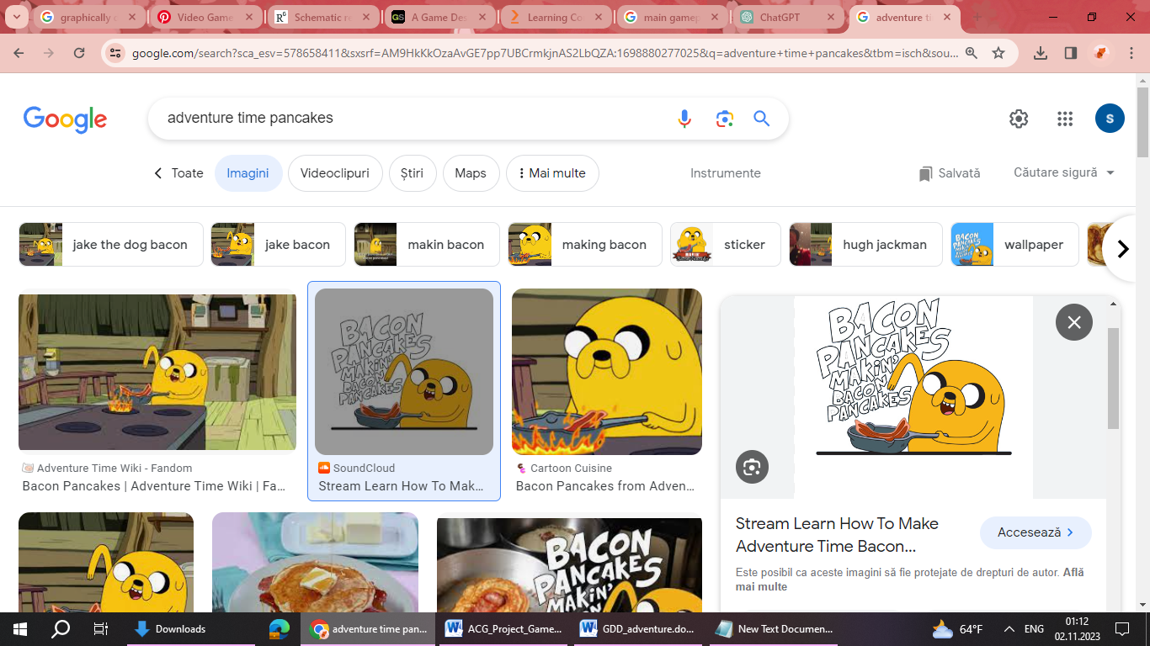 The game starts at the tree house of Finn and Jake, his brother. It is a fine summer morning, and Jake is making his special breakfast, pancakes with syrup. As Finn dances around the house, waiting for the food, the wind blows into the window and opens it. A strange and old-looking page flies directly into Jake's pan, ruining his pancakes. Finn realizes that this is one of the pages of the book of heroes. Forgetting about any breakfast, he takes his brother and decides to search the World of U for the lost pages of Enchiridion.

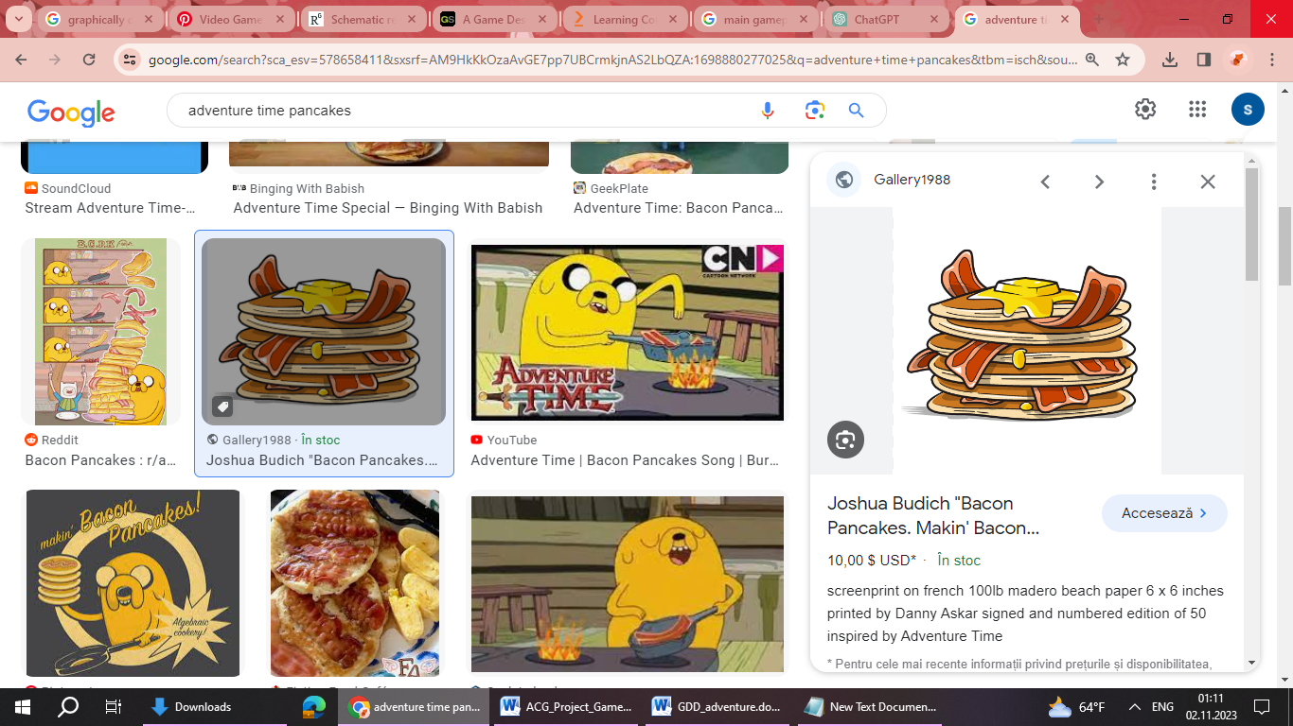Jake doesn’t want to leave the house because he is hungry and tired, but Finn quickly finds a solution. They will go to Tree trunks to bake them an apple pie and Jake can rest in his pocket, as he is a magical dog that can shrink and enlarge himself as he pleases.

***Storyline: Billy and the Enchiridion***

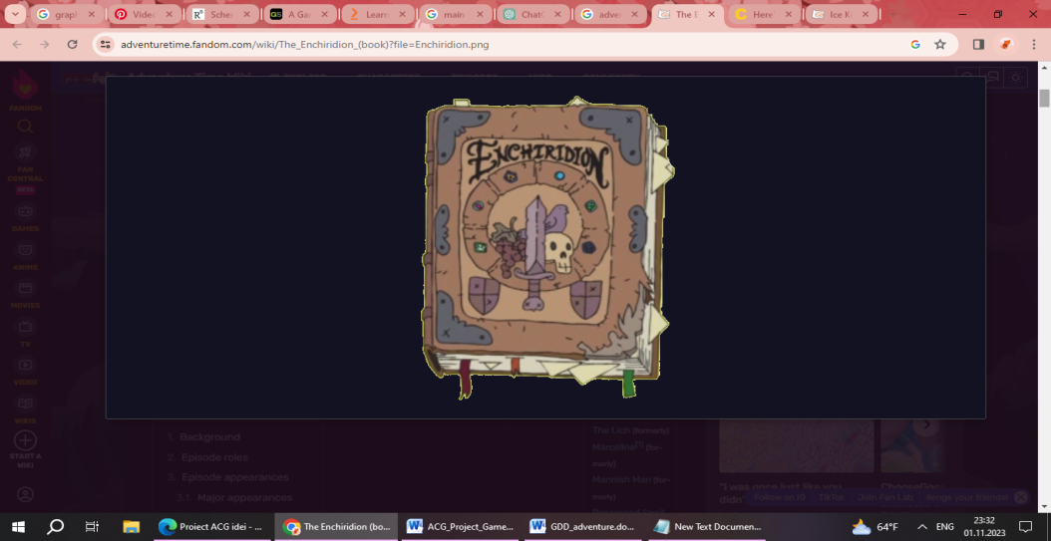Throughout the player's journey, Finn, wants to meet the legendary hero of all time in the land of OOO, Billy.

The Enchiridion, a powerful and ancient tome, has been scattered across the various kingdoms. Players must collect five pages from each kingdom to restore the complete book's knowledge, unlock its hidden secrets in order to meet the greatest hero of all time. Each page of the Enchiridion contains valuable information, spells, and insights that are crucial for the player's ultimate quest. As the player collects pages, they gain new abilities, magical powers, and access to hidden areas within the game world.

After collecting all the required pages, players return to the Verdant Plains (The Tree House) to reassemble the Enchiridion. Once complete, the Enchiridion reveals the location of a final, hidden chapter that holds the key to facing the ultimate challenge. With the Enchiridion in hand, the player returns to the Tree House to meet with Billy. Billy provides the player with additional guidance and insight into the final chapter's significance, and imparts a special ability or artifact to aid them in a possible, last and decisive final quest.

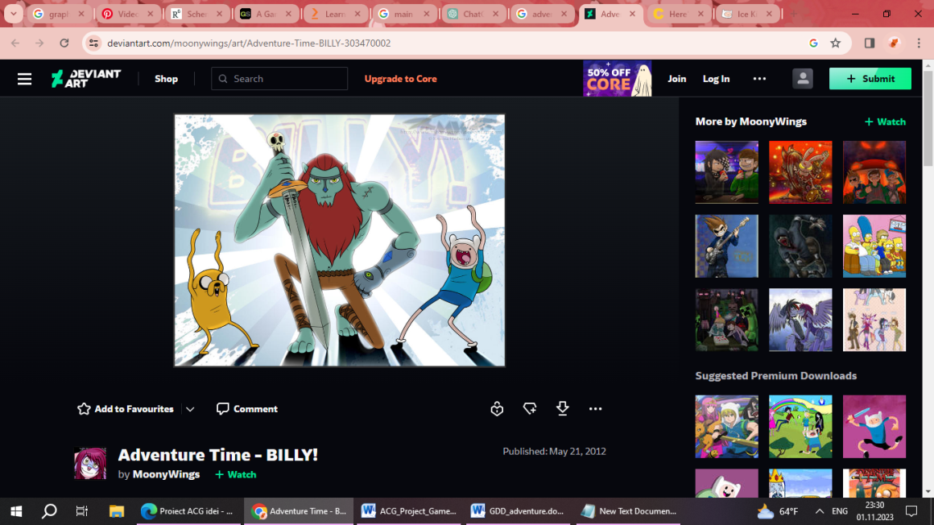

Armed with the knowledge and powers gained from the Enchiridion, the player embarks on a climactic journey to confront the ultimate antagonist or face the final challenge, with the fate of the kingdoms and the world hanging in the balance.

The player's successful completion of the final challenge brings about a resolution to the overarching story, potentially restoring peace to the Adventure Time world or uncovering a new chapter in its ongoing adventures.

* 1. Game World
     1. Areas, including the general description and physical characteristics as well as how it relates to the rest of the world (what levels use it, how it connects to other areas)

There are 5 areas of the game to explore in the magic land of OOO. The fantasy land is a new continental landmass on a post-apocalyptic Earth, centuries after a catastrophic nuclear war. The areas in which the player is most interested, are: The tree house, the candy kingdom, the Ice kingdom, the slime kingdom and last but not least the fire kingdom.

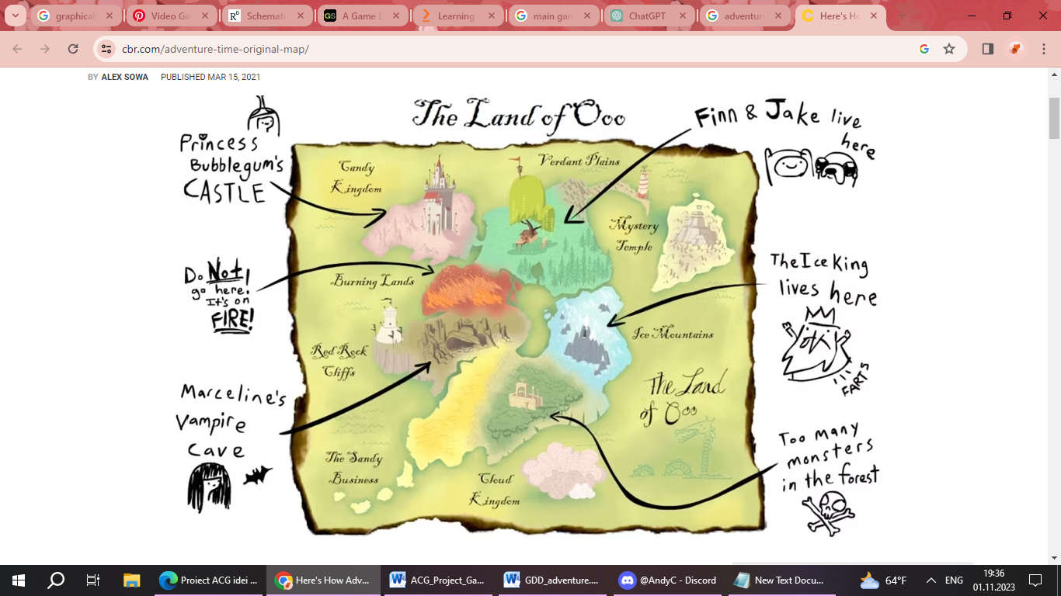

**Area Name:** Verdant Plains (The Tree House)

***General Description*:**

The Verdant Plains surround the iconic Tree House, a sprawling structure built into the branches of an enormous, ancient tree. The plains are lush and vibrant, filled with tall grasses, colorful wildflowers, and a gentle breeze that carries the scent of blooming vegetation. The Tree House itself is a whimsical amalgamation of rooms, platforms, and secret chambers, each with its own unique charm.

***Physical Characteristics:***

* The Tree House: A whimsically constructed treehouse with multiple levels, connected by bridges and ladders. Each level has its own theme and purpose, such as a library, living quarters, and a laboratory.
* Tall Grasses: The plains are covered in tall, swaying grasses that conceal hidden treasures and pathways.
* Enchanted Wildlife: Magical creatures, like talking animals and friendly spirits, roam the area, adding to the lively atmosphere.
* The Great Oak: The ancient tree that supports the Tree House, its massive roots spread out across the plains.

***Relation to Rest of the World:***

* Verdant Plains serve as the central hub in the world of Adventure Time. It is the starting point for most of the adventures, and it connects to various other kingdoms and realms. Players will return to the Verdant Plains between quests to regroup, gather supplies, and plan their next moves.

***Connections to Other Areas:***

* Ice Kingdom: Accessed through a magical portal located in a hidden chamber within the depths of the Tree House. This portal is activated after completing a special quest for the Ice King.
* Candy Kingdom: Players can travel to the Candy Kingdom by using the royal candy-themed hot air balloon stationed near the Tree House.
* Fire Kingdom: A secret passage within the Tree House leads to a volcanic chamber that connects to the Fire Kingdom. This passage is unlocked after completing a fiery-themed puzzle.
* Slime Kingdom: A secret door in the lower levels of the Tree House conceals a portal leading to the Slime Kingdom. This portal requires a special key, which the player can obtain through a side quest involving the Slime Princess.

***Gameplay Elements:***

Tree House Exploration: Players will navigate through the various levels and rooms of the Tree House, each with its own unique theme and challenges. They'll need to interact with objects, solve puzzles, and discover hidden passages to progress.

Jake the Companion: Jake, the magical shape-shifting dog, serves as the player's loyal companion. He offers hints, suggestions, and occasionally transforms into helpful forms to assist the player in overcoming obstacles or accessing new areas.

Dynamic Transformations: With Jake's shape-shifting abilities, players can temporarily take on various forms to gain special abilities. For example, Jake could transform into a bridge to help the player cross gaps or a ladder to reach higher platforms.

Interactive Objects and Gadgets: The Tree House is filled with interactive objects and gadgets. Players will need to manipulate switches, pull levers, and utilize tools found within the Tree House to unlock new areas and solve puzzles

Mystical Portals and Teleportation: The Tree House may contain magical portals that allow players to quickly travel between different levels or areas within the Tree House, providing a convenient means of navigation.

Time of Day Dynamics: The Tree House environment may change dynamically based on the time of day, affecting lighting, ambient sounds, and potentially revealing new opportunities or challenges.

***Quests:***

Main Quest: **" Pie for Jake"**  
  
Objective: Locate Tree Trunks and Convince Her to bake a Great Apple Pie.

Sub-objective:

* 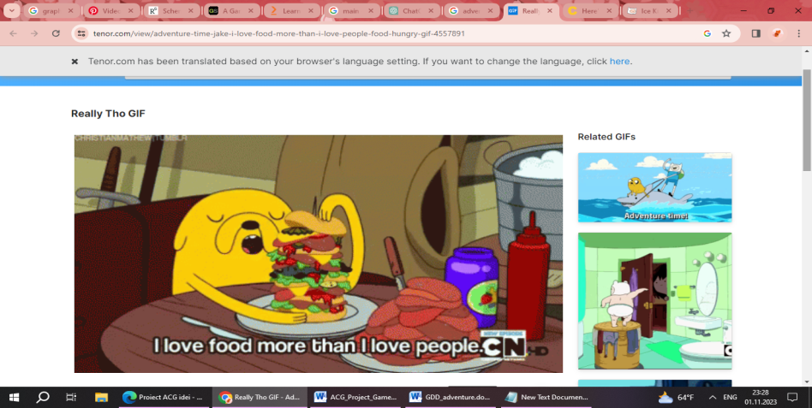Gather Information: Talk to residents of the Verdant Plains to gather information about Tree Trunks' whereabouts and her baking skills.
* Find Tree Trunks: Search the Verdant Plains, starting with her favorite spots, to locate Tree Trunks and ask for her help in baking a great apple pie.
* Convince Tree Trunks: Assist Tree Trunks with a small favor or complete a task for her in order to convince her to use her renowned baking skills to create a delicious apple pie for Jake.
* Gather Ingredients: Help Tree Trunks gather the necessary ingredients for the apple pie. This may involve foraging in the surrounding area or embarking on a mini-quest to obtain special ingredients.
* Assist in Baking: Work alongside Tree Trunks in her kitchen, providing assistance and following her expert guidance to ensure the apple pie turns out perfectly.
* Present the Pie to Jake: Deliver the freshly baked apple pie to a grateful and hungry Jake, strengthening your bond with him and potentially unlocking new abilities or perks, getting a page of the Enchridion and pursue the next mission.

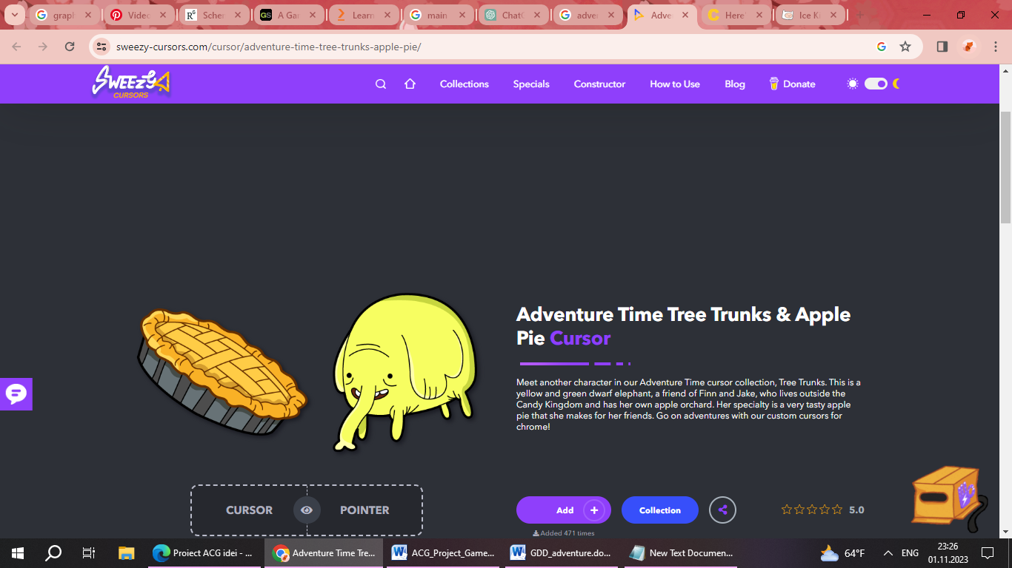

**Area Name**: Ice Kingdom

***General Description:***

* The Ice Kingdom is a frigid, snow-covered expanse ruled by the sad, pathetic and insane Ice King. Endless glaciers, frozen lakes, and towering ice formations dominate the landscape. The air is chilled, and the sky is often overcast, casting a pale blue glow across the kingdom. Despite the cold, the kingdom is teeming with life, including penguins, snow golems, and magical ice creatures.

***Physical Characteristics:***

* Glacial Peaks: Massive ice formations jut out of the ground, creating a surreal, otherworldly landscape.
* Ice Fortresses: Scattered across the kingdom are ancient ice fortresses, some inhabited by the Ice King's loyal subjects, while others lie abandoned and frozen in time.
* Frozen Caves: Beneath the surface, a network of icy caves conceals hidden chambers and treasures, accessible through tunnels carved by the Ice King's magic.

***Relation to Rest of the World:***

* The Ice Kingdom is one of the distinct realms that players can explore in Adventure Time. It is located to the east of the Verdant Plains and is accessible through a magical portal hidden within the Tree House. The kingdom plays a crucial role in the overarching story, as players must navigate its challenges and forge alliances with its inhabitants.

***Connections to Other Areas:***

* Verdant Plains (The Tree House): Accessed through a hidden portal in the depths of the Tree House, allowing players to travel between the two realms.
* Candy Kingdom: Players can reach the Candy Kingdom by traversing the treacherous Ice Bridge, a perilous path carved through the frozen tundra.

***Gameplay Elements:***

Ice-based Mechanics: Players will need to navigate through icy terrain, which may include slippery slopes, frozen lakes, and patches of thin ice. They'll need to master techniques for maintaining traction and stability in these conditions.

Cold Resistance and Warmth Management: Surviving in the Ice Kingdom requires managing the extreme cold. Players will need to acquire and utilize warm clothing, insulation, and heat sources to avoid freezing. This might include finding and using special items like hot drinks or warming spells.

Ice Magic: Players may acquire ice-based abilities, even the ninja book of ice king’s, allowing them to manipulate ice and snow. This could include freezing enemies or elements of the environment to create platforms or block pathways.

Avalanche Escapes: The player may face challenges involving avalanches triggered by certain actions or events. They'll need to quickly navigate treacherous slopes, dodge falling ice and snow, and find shelter to survive the danger.

Crystal Collecting: Crystals may be scattered throughout the Ice Kingdom, serving as valuable resources or quest objectives. Players will need to collect these crystals to progress in the game.

Snowball Combat: Players may engage in combat scenarios where they use snowballs as projectiles to fend off enemies. Different types of snowballs or snow-based weapons might be available for crafting and use.

Aurora Borealis Navigation: The northern lights (aurora borealis) may play a role in navigation and exploration, acting as a guide or marker for specific objectives or hidden locations within the Ice Kingdom.

***Quests:***

Main Quest: ***" Frozen Confrontation"***

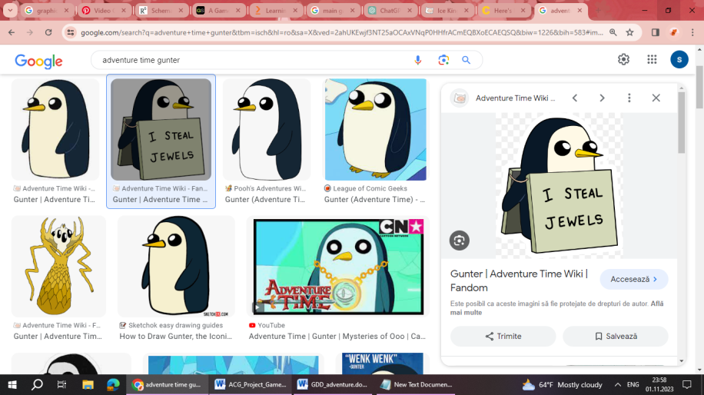Objective: Confront and Teach Ice King a Lesson for His Actions, as you get the next page of the Enchridion.

Sub-objective:

* Journey to the Ice Kingdom: Make your way to the Ice Kingdom, navigating through the frozen landscape and overcoming any obstacles or adversaries along the way.
* Receive Peppermint Butler's Request: Speak with Peppermint Butler, who seeks your assistance in dealing with Ice King's mischievous behavior. He provides you with a magical buff to aid in the confrontation. A blue potion is stored. This potion will significantly increase your health for the remainder of the mission.
* Prepare for Battle: Equip the provided buff from Peppermint Butler to bolster your strength and resilience against the icy challenges you'll face in the Ice Kingdom.
* Locate Ice King's Lair: Use your knowledge of the Ice Kingdom's terrain to find Ice King's lair, where he's been causing trouble for Princess Bubblegum.
* Confront Ice King: Engage in a battle with Ice King, using your enhanced abilities and tactics to teach him a lesson and put an end to his disruptive behavior.
* Deliver a Stern Message: After defeating Ice King, deliver a stern message to him about forcing princess Bubblegum to marry him.

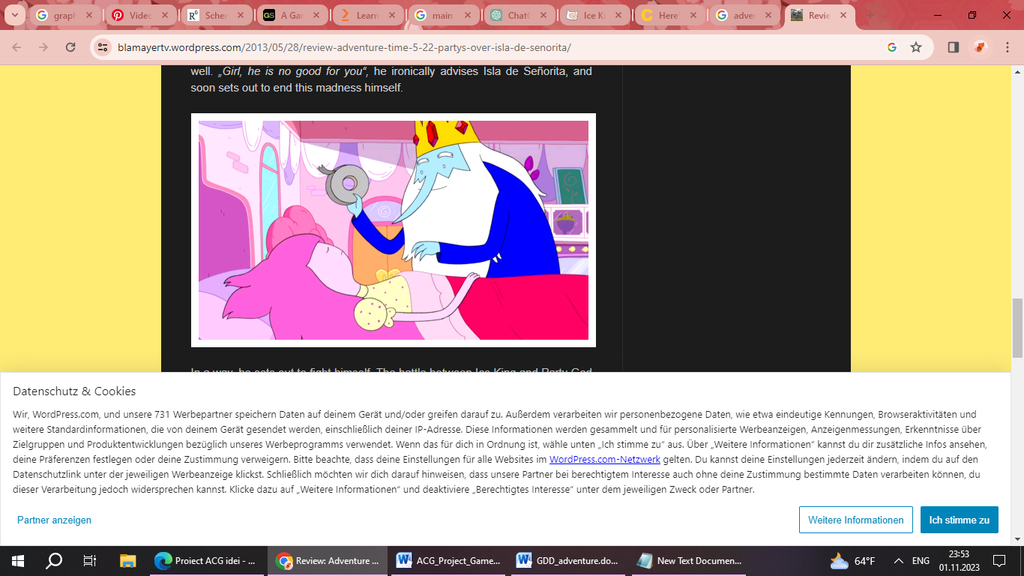

* Report Back to Peppermint Butler: Return to Peppermint Butler and inform him of the successful confrontation with Ice King. Receive any additional instructions or rewards he may offer for your assistance.

**Area Name:** Slime Kingdom

***General Description***:

* The Slime Kingdom is a bizarre and gooey realm ruled by the amiable and shape-shifting Slime Princess. The landscape is characterized by rolling hills of colorful, semi-translucent slime in various shades, ranging from vibrant greens to iridescent blues. Pools of slime dot the landscape, and strange, blob-like plants grow among the hills. The air is filled with a pleasant, slightly tangy scent, and the atmosphere is often damp and cool.

***Physical Characteristics:***

* Slime Flora and Fauna: The kingdom is home to a variety of unique slime-based flora and fauna, including bouncing slime flowers and creatures with the ability to morph and change shape.
* Slime Ponds: Pools of semi-liquid slime act as natural features of the landscape, with some serving as recreational areas for the inhabitants.
* Slime Structures: The Slime Kingdom is dotted with quirky, malleable structures that can be reshaped or molded by the residents to suit their needs or desires.

***Relation to Rest of the World:***

* The Slime Kingdom is a peculiar and vibrant realm situated to the south of the Verdant Plains and the Candy Kingdom. It provides a stark contrast to the more traditional and elemental landscapes of its neighboring kingdoms. Adventurers will need to adapt to the unique properties of slime and navigate its unconventional terrain.

***Connections to Other Areas:***

* Verdant Plains (The Tree House): A secret door in the lower levels of the Tree House conceals a portal leading to the Slime Kingdom. This portal requires a special key, which the player can obtain through a side quest involving the Slime Princess.
* Candy Kingdom: While the Slime Kingdom and the Candy Kingdom are not directly connected, players can return to the Verdant Plains and then utilize alternative methods of transport, such as magic or special vehicles, to travel between the two realms.

***Gameplay Elements:***

Slime Manipulation: Players can interact with the unique properties of slime in the Slime Kingdom. This includes bouncing on slime surfaces, using slime-based tools, and even transforming into different slime forms to solve puzzles or access hidden areas.

Slime-based Challenges and Minigames: The Slime Kingdom could feature a variety of challenges and minigames that make use of the unique properties of slime. This might include races on bouncing platforms, target-shooting games using slime projectiles, or timed platforming trials.

Interactions with Slime Residents: Players will have opportunities to interact with the friendly inhabitants of the Slime Kingdom, often involving quests or tasks that require them to assist or collaborate with the slime-based characters.

Slime Crafting and Alchemy: Players may have the option to collect and combine different types of slime to create useful items, potions, or even temporary enhancements that can aid in their journey through the Slime Kingdom.

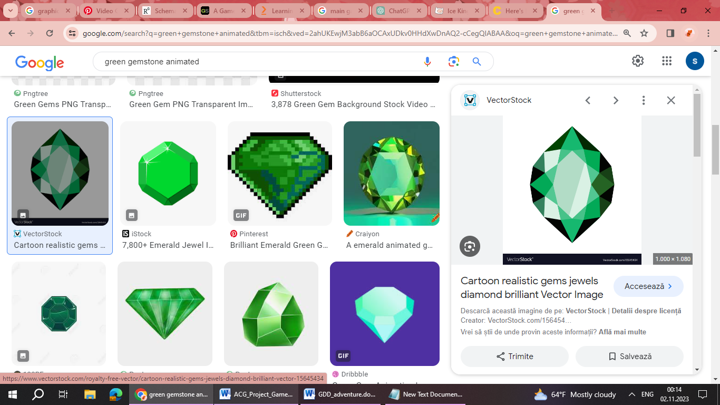Slime-Enhanced Abilities: Players may acquire special items or equipment within the Slime Kingdom that grant temporary enhancements or abilities, such as increased jumping height, improved mobility on slime surfaces, or the ability to temporarily merge with and control certain slime-based creatures.

***Quests:***

Main Quest: ***" Slime's Royal Quest"***

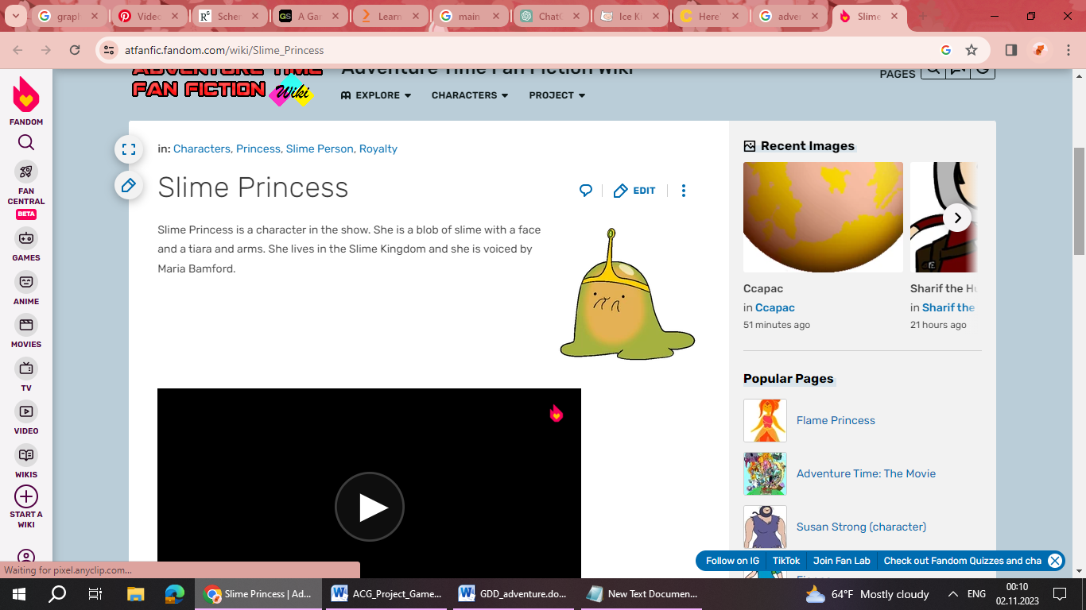Objective: Help the Royal Subject Find the Lost Gemstone for the Princess Crown

Sub-objectives:

* Meet the Royal Subject: Upon entering the realm of slime, you encounter a member of the royal court who politely requests your assistance in locating the lost gemstone of the princess crown.
* Gather Information: Speak with the royal subject to gather clues and information about the possible whereabouts of the lost gemstone. Investigate slime-covered areas and seek out potential leads.
* Explore the Slime Kingdom: Traverse through the vibrant and gooey terrain of the Slime Kingdom, following leads and searching for any signs of the missing gemstone.
* Overcome Slime Challenges: Encounter challenges unique to the realm of slime, including navigating through viscous slime pools, interacting with friendly slime creatures, and utilizing the environment to progress.
* Discover the Gemstone's Location: Through exploration and interaction, narrow down the possible location of the lost gemstone within the Slime Kingdom.
* Retrieve the Green Potion: Along your journey, you come across a hidden cache containing a green potion. This potion enhances your weapon strength, providing a valuable advantage as you continue your quest.
* Locate the Lost Gemstone: Use the gathered information to pinpoint the exact location of the lost gemstone within the Slime Kingdom.

* 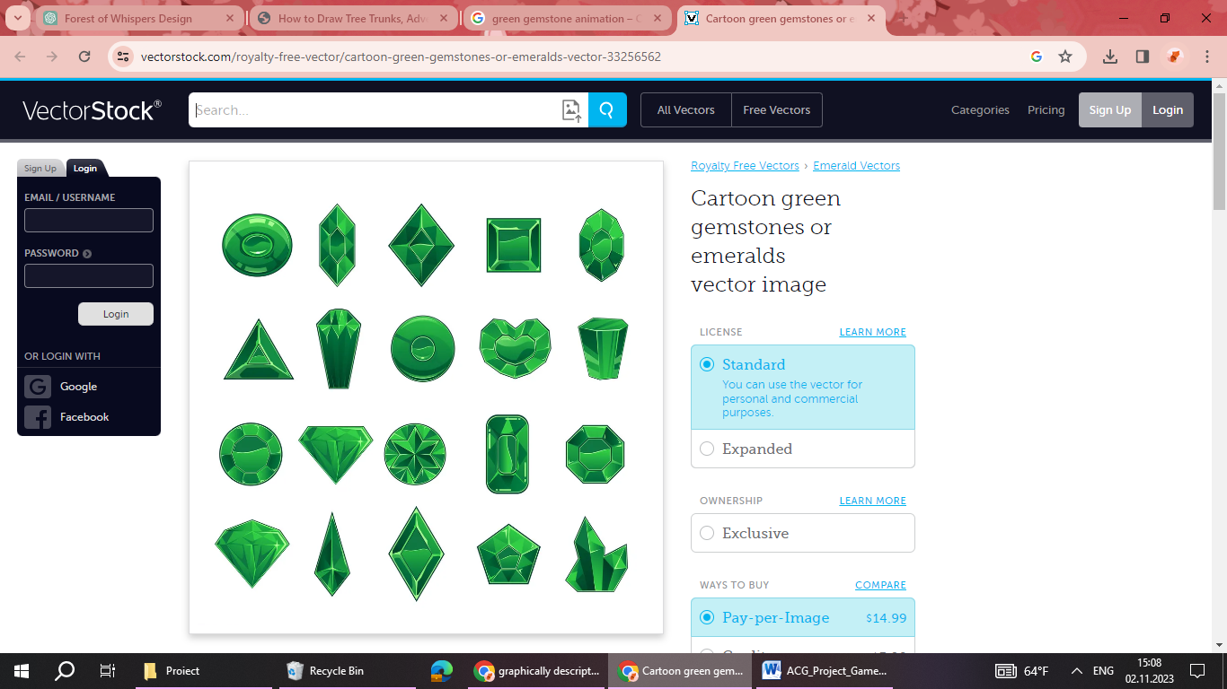Return the Gemstone to the Royal Subject: Once you've found the gemstone, return it to the royal subject, who is deeply grateful for your assistance.
* Receive the Third Page of the Enchiridion: As a reward for your successful mission, the royal subject presents you with the third page of the Enchiridion, providing you with invaluable knowledge and power.

**Area Name**: Fire Kingdom

***General Description***:

* The Fire Kingdom is a realm of eternal flames and molten landscapes, ruled by the hot-headed Flame King. It's a harsh and unforgiving environment, with rivers of lava flowing through rocky canyons and towering volcanoes spewing ash and embers into the air. The sky is often filled with billowing smoke and the horizon is painted with the fiery hues of sunset. Heat radiates from every surface, creating a constant shimmering haze.

***Physical Characteristics:***

* Lava Pools: The kingdom is dotted with bubbling pools of molten lava, some of which form natural barriers or obstacles to navigate.
* Volcanic Peaks: Towering volcanoes loom over the landscape, their peaks wreathed in smoke and fire. These are the sources of the kingdom's intense heat and energy.
* Obsidian Formations: Jagged formations of obsidian rock, formed from cooled lava, create treacherous terrain to traverse.
* Flame Creatures: Creatures native to the Fire Kingdom are adapted to the extreme heat, with flaming manes and ember-covered hides.

***Relation to Rest of the World:***

* The Fire Kingdom is a formidable and challenging realm, situated to the east of the Verdant Plains and the Candy Kingdom. It stands as a stark contrast to the lush and sweet environments of its neighboring kingdoms. Adventurers will need to master fire-resistant gear and skills to survive and thrive in this fiery domain.

***Connections to Other Areas:***

* Verdant Plains (The Tree House): A secret passage within the Tree House leads to a volcanic chamber, which connects to the Fire Kingdom. This passage is unlocked after completing a fiery-themed puzzle, allowing players to access the kingdom directly.
* Candy Kingdom: Although the Candy Kingdom and the Fire Kingdom are not directly connected, players can travel from one to the other by first returning to the Verdant Plains and then using alternative methods of transport, such as magic or special vehicles.

***Gameplay Elements:***

Heat Management: The Fire Kingdom presents a constant challenge of managing heat levels. Players must find ways to stay cool, whether through specialized gear, seeking shade, or using heat-resistant abilities. Prolonged exposure to extreme heat could lead to exhaustion or even damage to the player character.

Fire-Resistant Gear: Players will need to acquire and equip fire-resistant equipment to navigate the scorching terrain of the Fire Kingdom. This gear may offer protection against extreme temperatures, allow the player to walk on hot surfaces, and provide resistance to fire-based attacks from enemies.

Volcanic Obstacles: The landscape of the Fire Kingdom is fraught with volcanic hazards, including spurting geysers of lava and collapsing rock formations. Players will need to time their movements carefully to avoid these dangers.

Fire-Based Abilities: Players may acquire special abilities related to fire manipulation. This could include the ability to summon fire projectiles, create protective barriers of flames, or even temporarily become immune to fire damage.

Elemental Enemies: The Fire Kingdom is home to a variety of elemental creatures, including fire imps, magma golems, and ember sprites. Combat in this realm will involve adapting to their fiery attacks and exploiting their elemental weaknesses.

Interaction with Fire Kingdom Denizens: Players will have opportunities to interact with the inhabitants of the Fire Kingdom, potentially engaging in quests or activities that require them to assist or collaborate with the fiery denizens.

***Quests:***

Main Quest: ***" Inferno's Reckoning"***

Objective: Confront and Imprison the Bad Father of Fire Princess

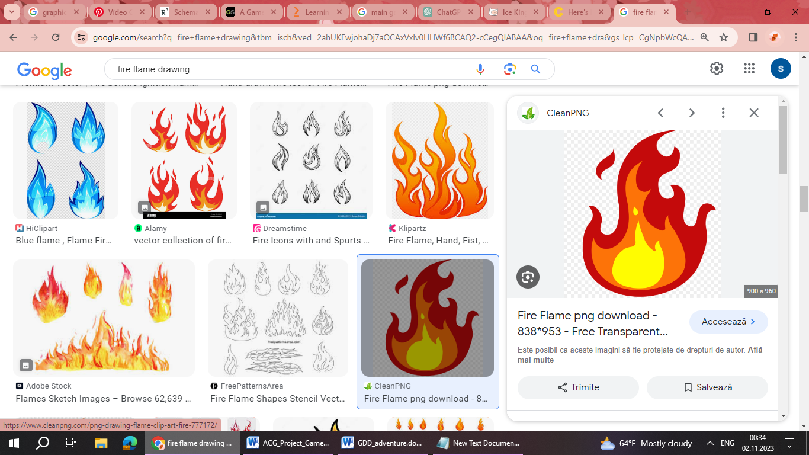Sub-objective:

* Seek Flambo's Aid: Locate Flambo, the fire elemental, who provides you with a powerful buff specifically tailored to the challenges of the fiery realm, a red potion. This potion significantly increases your damage output for the remainder of the mission.
* Prepare for the Fire Realm: Equip the buff bestowed by Flambo to enhance your damage output and resilience against the intense heat and flames of the Fire Kingdom.
* Enter the Realm of Fire: Step into the scorching landscape of the Fire Kingdom, navigating through the molten terrain and preparing to face the formidable foe.
* 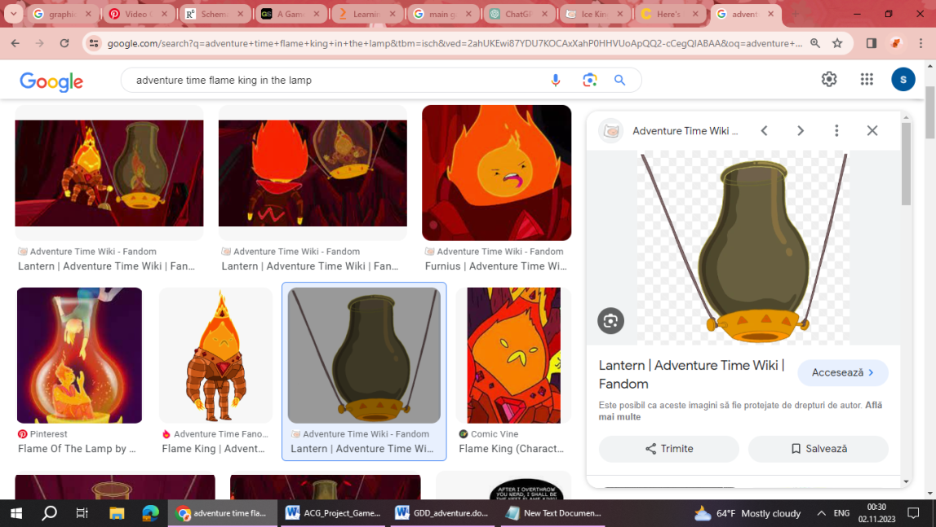Locate the Bad Father: Use your knowledge of the Fire Kingdom's terrain to track down the bad father of Fire Princess, who has been causing trouble.
* Engage in Battle: Confront the bad father in a heated battle, utilizing your enhanced abilities and tactics to overpower him.
* Imprisonment in the lantern: Once defeated, use a special enchanted gas lamp to imprison the bad father, ensuring he can no longer wreak havoc.
* Report Back to Flambo: Return to Flambo and inform him of your success in confronting and imprisoning the bad father. Receive any additional instructions or rewards he may offer for your assistance.

**Area Name**: Candy Kingdom

***General Description***:

* The Candy Kingdom is a whimsical land made entirely of candy and confections. The buildings are constructed from gumdrops, lollipops, and gingerbread, and the streets are paved with candy-coated cobblestones. A sweet aroma fills the air, and colorful rainbows arc across the sky. The inhabitants, including Princess Bubblegum and her candy subjects, are animated, sentient sweets.

***Physical Characteristics:***

* Candy Architecture: The buildings in the kingdom are tall, whimsical structures with frosting accents and candy cane spires.
* Candy Forest: Beyond the main city, a candy forest extends, filled with sugar trees, chocolate rivers, and gumdrop bushes.
* Gumball Guardians: Enormous guardians made of gumballs stand sentinel at the entrance to the kingdom, protecting it from potential threats.
* Princess Bubblegum's Castle: At the heart of the kingdom lies a grand castle made of translucent pink candy, adorned with gumdrop turrets and sugar crystal windows. It's the residence of Princess Bubblegum and serves as the central hub of the kingdom's operations.
* Candy Subjects: The inhabitants of the Candy Kingdom are animated, sentient sweets and candy people. They go about their daily lives, engaging in activities like shopping for candy groceries and playing in candy parks.
* Peppermint Butler: A dapper and loyal servant, Peppermint Butler assists Princess Bubblegum in various capacities, often offering his magical expertise.

***Relation to Rest of the World:***

* The Candy Kingdom is a key location in the Adventure Time universe, acting as both a vibrant hub of activity and a strategic stronghold. It is centrally-west located, making it a natural meeting point for adventurers and a gateway to various other realms.

***Connections to Other Areas:***

* Verdant Plains (The Tree House): Players can return to the Verdant Plains using a hot air balloon stationed in the central square of the Candy Kingdom.
* Ice Kingdom: Accessible via the treacherous Ice Bridge, players can navigate the icy terrain to reach the neighboring realm.

***Gameplay Elements:***

Sweet Platforming: The Candy Kingdom features platforming challenges where players will navigate through sugary landscapes, leaping between gumdrop platforms, swinging on licorice vines, and bouncing on giant marshmallow cushions.

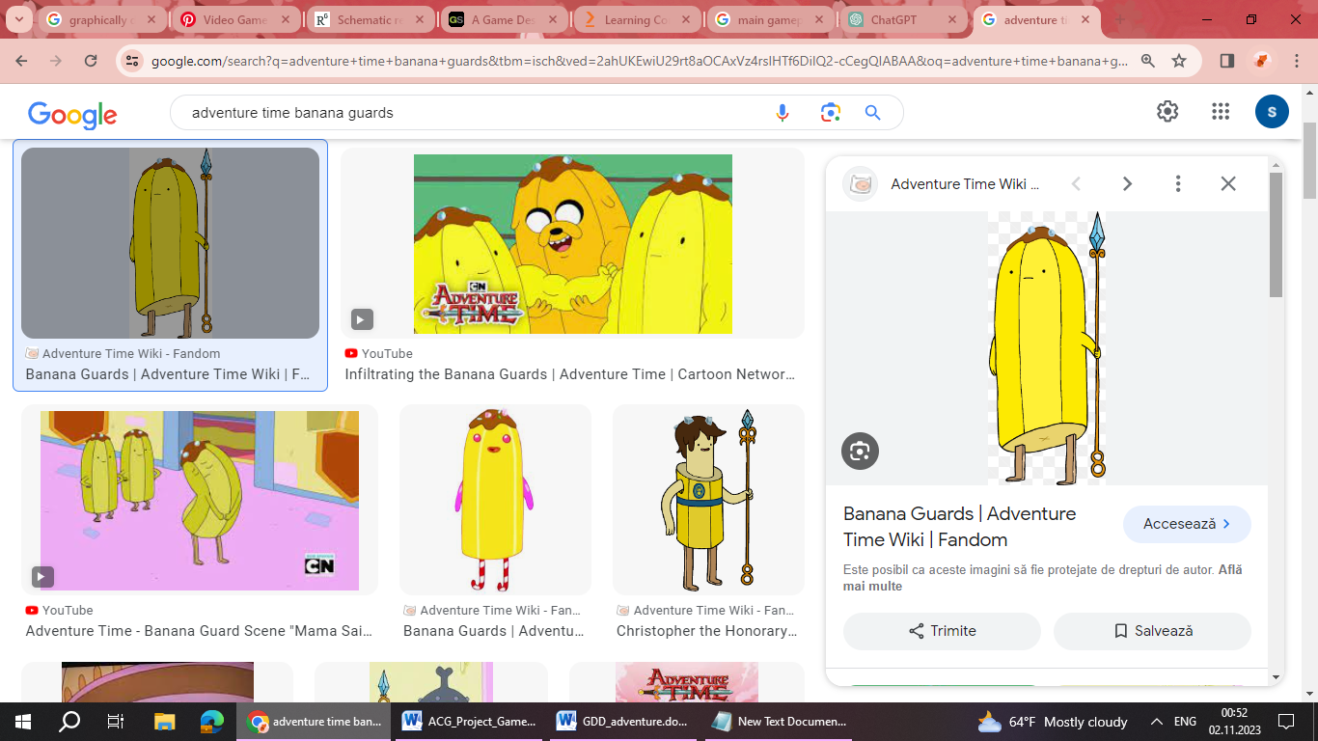Interactive Candy Architecture: Players can interact with the candy structures within the kingdom. This may involve rearranging and modifying portions of the environment to solve puzzles, reveal hidden passages, or create new platforms.

Candy Alchemy and Cooking: In the Candy Kingdom, players may discover cooking stations and alchemical setups where they can combine different types of candy to create useful items, concoctions, or even temporary enhancements.

Sweet Tooth Power-ups: Players may encounter special power-ups like candy-themed speed boosts, temporary invincibility from a sugar rush, or the ability to launch themselves like a candy-coated projectile.

Candy Citizens and Quests: Players can interact with the inhabitants of the Candy Kingdom, taking on quests or tasks that involve helping the candy people with various sweet-themed challenges or dilemmas.

Gooey Obstacles and Traps: The kingdom may feature sticky obstacles like gum-covered surfaces, gooey traps, and sugary quicksand. Players will need to carefully navigate these challenges to progress.

Candy Confections as Currency: Players might collect various types of candy confections as a form of in-game currency. These confections can be traded with NPCs for special items, upgrades, or hints to solve puzzles.

***Quests:***

Main Quest: ***" Sticky Solutions"***

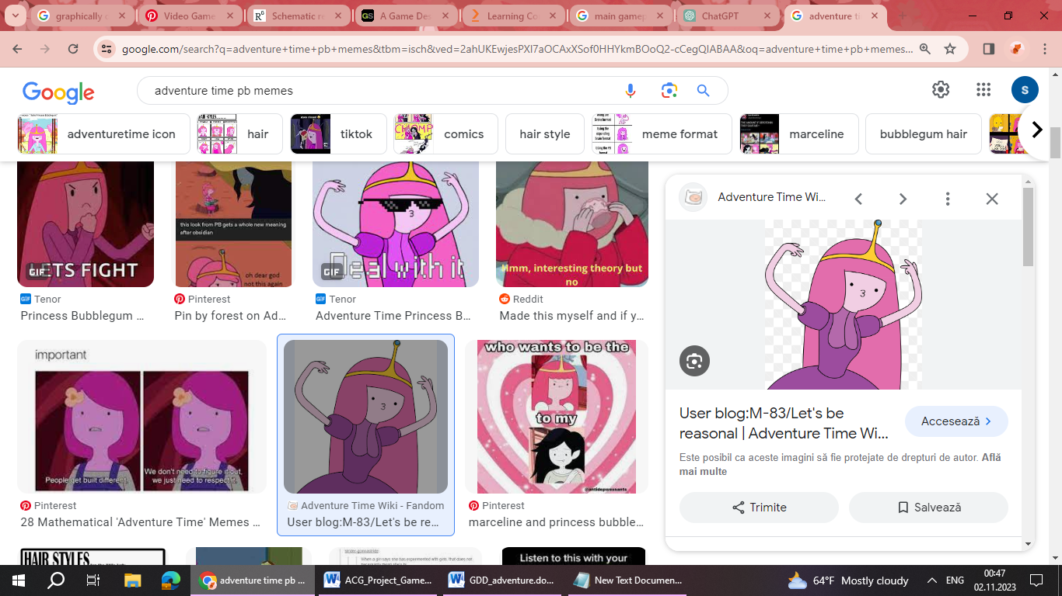Objective: Seek Help from the Princess of Gum to Find the Last Enchiridion Page and Meet Billy.

Sub-objective:

* Discover the Gum Kingdom: Enter the Gum Kingdom, a colorful realm of sugary landscapes and bouncy surfaces, where the Princess of Gum resides.
* Locate the Princess of Gum: Navigate through the Gum Kingdom, bouncing on gumdrop platforms and avoiding sticky traps, to find the Princess of Gum in her gum castle.
* Request Assistance: Approach the Princess Bubblegum and humbly ask for her help in locating the final page of the Enchiridion, explaining the importance of meeting your hero, Billy.
* Gum Kingdom's Buff: Upon your arrival in the Gum Kingdom, you discover a hidden potion that grants you a special buff, enhancing your agility and mobility within the realm. The pink potion significantly increases your agility for the remainder of the mission.
* Receive Clues from the Princess: The Princess of Gum provides you with valuable clues and information about the whereabouts of the last Enchiridion page, based on her knowledge of the Gum Kingdom.
* Follow the Gum Trail: Utilize the Princess's clues to follow a trail of gum-based landmarks and puzzles leading you to the location of the final Enchiridion page.
* 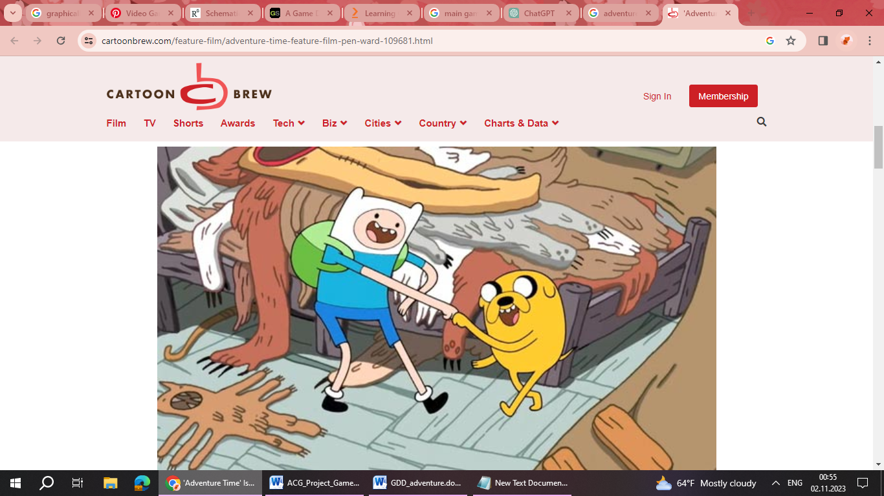Find the Last Enchiridion Page: Use the provided clues to pinpoint the exact location of the last Enchiridion page within the Gum Kingdom.
* Return to the Princess of Gum: Inform the Princess of Gum about your success in finding the final Enchiridion page and express your gratitude for her assistance.
* Prepare to Meet Billy: With the last Enchiridion page in hand, make your way back to the Verdant Plains (The Tree House) to prepare for the momentous meeting with your hero, Billy.

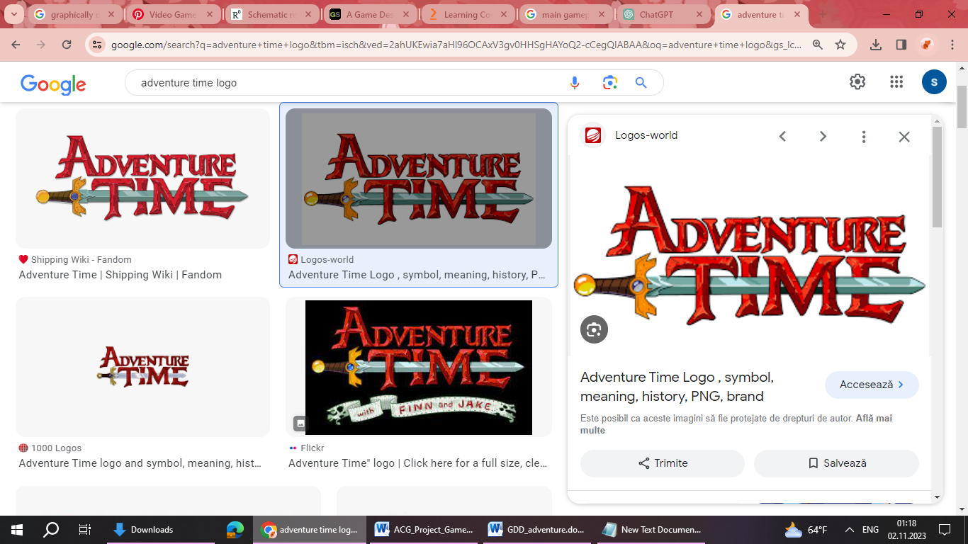

* 1. Characters. Each character should include the back story, personality, appearance, animations, abilities, relevance to the story and relationship to other characters

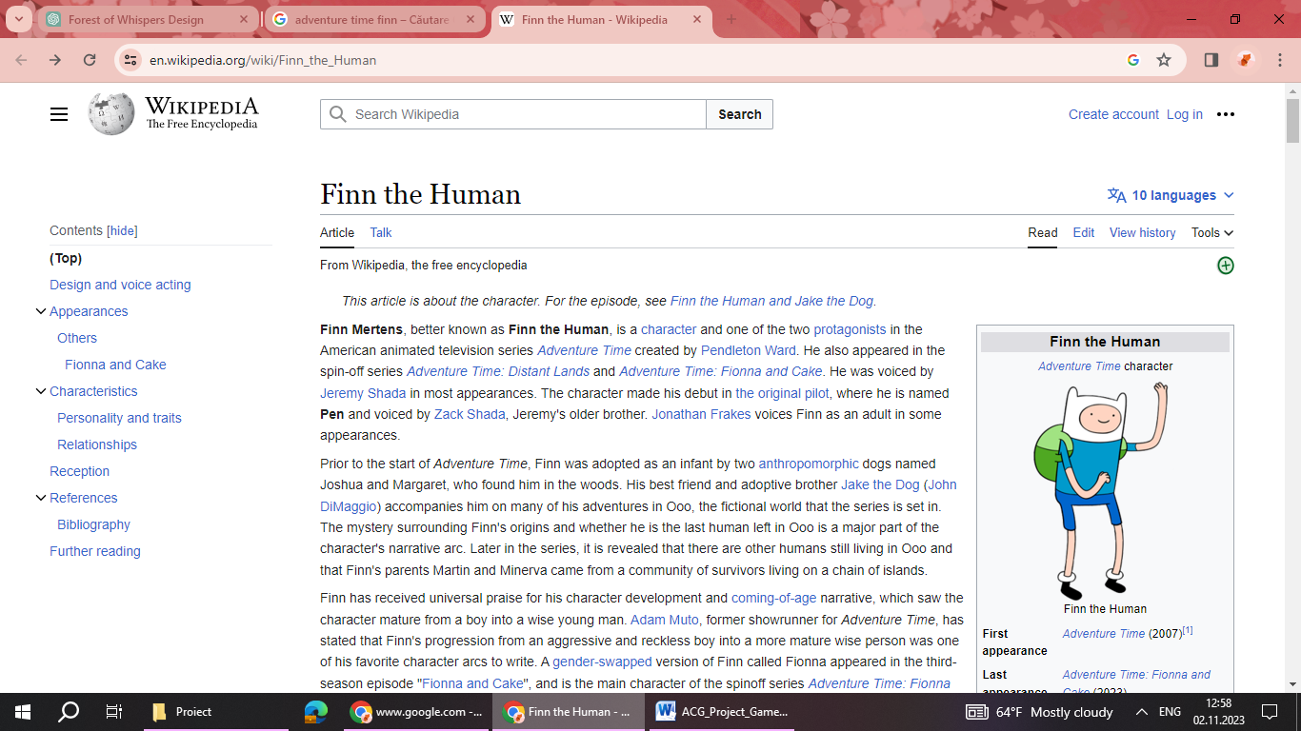

**Backstory**

Finn, also known as Finn the Human, is the main protagonist of Adventure Time. He was found in the forest as a baby by Jake's parents and was raised alongside Jake as his adoptive brother. Finn grew up as an adventurer in the Land of Ooo, constantly seeking out quests and challenges.

**Personality**

Finn is known for his unwavering optimism, bravery, and sense of justice. He's incredibly kind-hearted, always striving to do what's right, even in the face of danger. He's energetic and eager, often approaching challenges with a cheerful and determined attitude. Finn also possesses a strong moral compass, which sometimes leads him to make difficult decisions for the greater good.

**Appearance**

Finn is a human boy with short, blond hair, large expressive blue eyes, and a characteristic hat that covers his ears. He typically wears a blue tunic, dark blue shorts, white socks, and brown shoes. As he grows older, his appearance changes, reflecting his journey from a young adventurer to a more mature hero.

**Animations**

Running: Finn's animation shows him sprinting with enthusiastic energy.

Swordplay: When engaged in combat, Finn's movements are quick, precise, and reflect his extensive training in swordsmanship.

Jumping: Finn's jumps are acrobatic and dynamic, showcasing his agility.

**Abilities**

Swordsmanship: Finn is a skilled swordsman, often wielding his trusty sword, the "Grass Sword." He's proficient in various forms of combat and can take on a wide range of adversaries.

Agility: He's remarkably agile and quick on his feet, allowing him to navigate through challenging terrains with ease.

Problem Solving: Finn's quick thinking and resourcefulness enable him to solve complex puzzles and overcome obstacles.

Combat Techniques: Over time, Finn learns and masters various combat techniques, incorporating both offensive and defensive moves.

**Relevance to the Story**

Finn's journey is central to the Adventure Time narrative. He's the catalyst for most of the adventures and quests that take place in the Land of Ooo. His growth and development, both as a hero and as a person, shape the overarching storyline, making him a linchpin in the fate of the world.

**Relationship to Other Characters**

Jake the Dog: Finn's adoptive brother and best friend. They share an unbreakable bond and often embark on adventures together. Jake's easy-going nature complements Finn's spirited personality.

Princess Bubblegum: Finn has a long-standing crush on Princess Bubblegum. They have a deep mutual respect and friendship.

Billy: Billy is Finn's childhood hero and a legendary warrior. Finn looks up to Billy with immense admiration, considering him a role model. Their relationship is one of great respect and aspiration. When Finn finally meets Billy, he is overjoyed and seeks to learn from him. Their interactions are filled with mentorship and encouragement.

Ice King: Initially, Finn sees Ice King as a villain due to his constant attempts to kidnap princesses. However, as the story progresses, Finn begins to sympathize with Ice King's tragic backstory and the mental toll the crown has taken on him. Finn occasionally shows empathy and even tries to help Ice King regain some of his lost humanity.

Peppermint Butler: Finn's relationship with Peppermint Butler is friendly, but there's an underlying sense of caution due to Peppermint Butler's occasional involvement in dark magic. They occasionally team up for missions when Peppermint Butler's expertise is required.

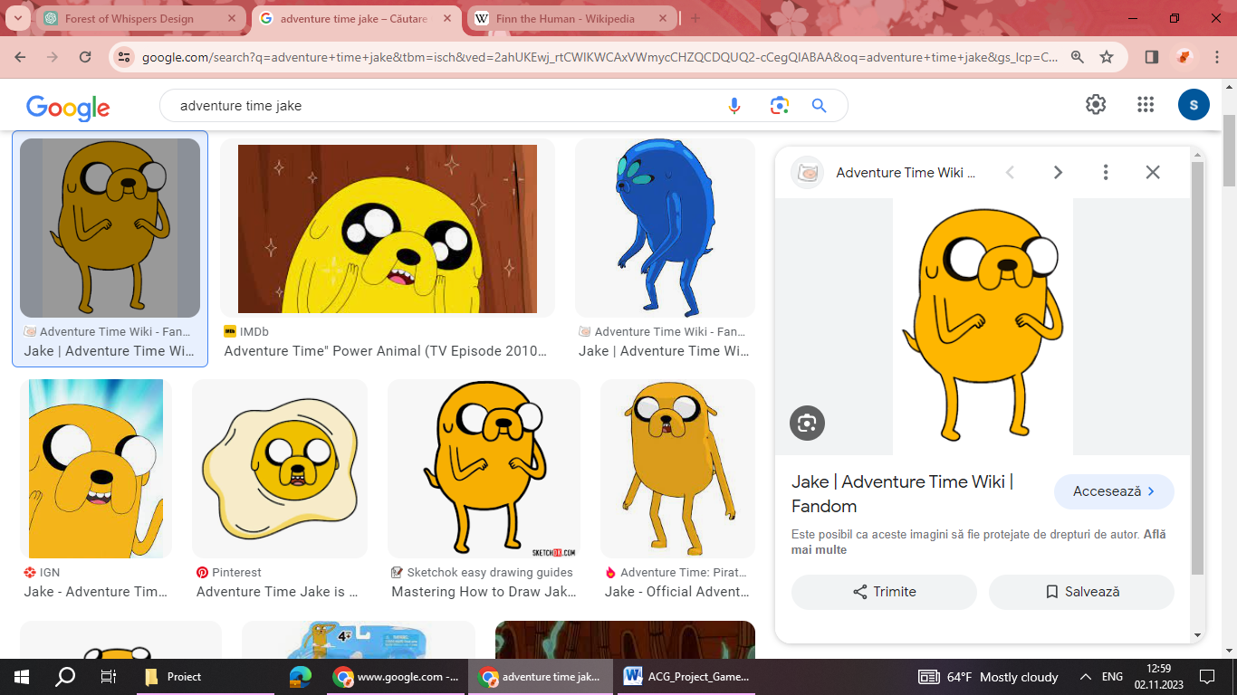

**Backstory**

Jake the Dog is Finn's loyal and magical shape-shifting companion. He was born from a magical puddle and later adopted by Joshua and Margaret, making him Finn's adoptive brother. Jake grew up alongside Finn and the two share a deep, unbreakable bond.

**Personality**

Jake is known for his laid-back, easy-going nature. He's often the voice of reason to Finn's impulsiveness, providing a calm and rational perspective. Despite his relaxed demeanor, Jake is fiercely protective of Finn and his friends. He's also incredibly supportive, always encouraging Finn and helping him through tough situations. Jake is known for his sense of humor and love of adventure.

**Appearance**

Jake is a stretchy, yellow dog with large, expressive eyes and a big, toothy grin. He can alter his size and shape at will, allowing him to transform into various forms and sizes, from a small pocket-sized version to a giant. He typically wears a pair of shorts and a hat, reflecting his casual and carefree nature.

**Animations**

Shape-shifting: Jake's animations involve him seamlessly morphing into different forms, showcasing his remarkable shape-shifting abilities.

Stretching: Jake's limbs elongate when he needs to reach distant objects or cover large distances.

Comedic Gestures: Jake often uses exaggerated movements and facial expressions to convey humor and emotions.

**Abilities**

Shape-Shifting: Jake's primary ability allows him to change his form, enabling him to take on various roles and adapt to different situations.

Stretching: Jake can stretch his body to great lengths, making him a versatile asset in reaching high places or spanning wide gaps.

Size Alteration: He can change his size, becoming either very small or enormously large, which proves useful in various scenarios.

Morphing Objects: Jake can transform objects into different shapes, which comes in handy for solving puzzles or creating tools on the fly.

**Relevance to the Story**

Jake is not only Finn's best friend and adoptive brother, but he's also a crucial part of the Adventure Time narrative. His shape-shifting abilities provide creative solutions to challenges, and his wise counsel often guides Finn through their adventures.

**Relationship to Other Characters**

Finn the Human: Jake and Finn share an inseparable bond. They've faced countless adventures and challenges together, relying on each other's strengths and support. Their relationship is one of deep trust, camaraderie, and mutual understanding.

Princess Bubblegum: Jake has a friendly and respectful relationship with Princess Bubblegum. He appreciates her intelligence and often supports Finn in his interactions with her. Jake's easy-going nature complements Princess Bubblegum's more reserved demeanor.

Flambo: Flambo is a fire elemental and a recurring character in Adventure Time. He and Jake share a friendly and amicable relationship. Flambo is known to have provided Jake with assistance, particularly in the form of specific buffs or potions that enhance Jake and Finn's abilities when they embark on quests or faces challenges related to fire.

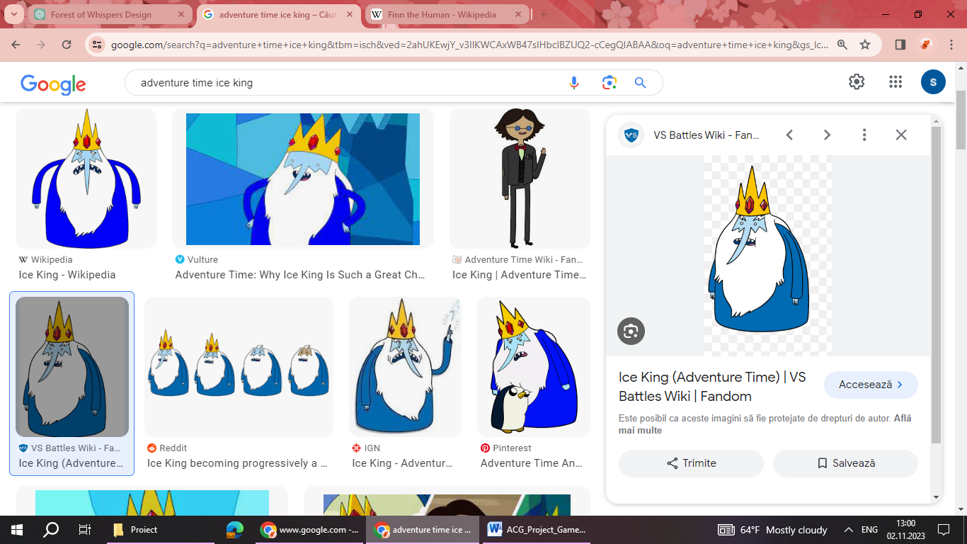

**Backstory**

The Ice King, originally known as Simon Petrikov, was once a kind and compassionate archaeologist. However, after putting on the enchanted crown of the Ice King, his sanity began to deteriorate, and he transformed into a tragic and misunderstood figure. The crown grants him ice-based powers, but at a great cost to his memories and mental stability.

**Personality**

The Ice King's personality is characterized by a mixture of loneliness, eccentricity, and a desire for companionship. He often comes across as eccentric and erratic, with a penchant for creating imaginative, albeit misguided, plans to capture princesses. Beneath his sometimes antagonistic behavior lies a deep sense of longing and sadness.

**Appearance**

The Ice King's appearance is defined by his tattered blue robe, crown, and long white beard. The crown itself is adorned with jewels and has a distinctive shape. The ice powers granted by the crown also manifest in his icy blue skin and flowing white hair.

**Animations**

Casting Ice Magic: The Ice King's animations involve conjuring and manipulating ice and snow to create various constructs or attacks.

Flight on Ice Clouds: He often uses his powers to create clouds of ice to float or fly on.

Expressive Gestures: The Ice King's movements reflect his dramatic and expressive personality.

**Abilities**

Ice Magic: The Ice King has formidable ice-based abilities, allowing him to freeze objects, create ice constructs, and summon blizzards.

Immunity to Cold: Due to the effects of the crown, the Ice King is immune to extreme cold and can withstand freezing temperatures.

Creating Minions: He has the ability to create living ice-based creatures, which serve as companions or henchmen.

**Relevance to the Story**

The Ice King plays a complex and significant role in the Adventure Time narrative. His tragic backstory, transformation, and pursuit of companionship serve as a recurring theme throughout the series. His actions, often driven by his desire for a genuine connection, impact many of the characters in the Land of Ooo.

**Relationship to Other Characters**

Princess Bubblegum: The Ice King's obsession with capturing princesses, particularly Princess Bubblegum, is a central aspect of his character. Despite her exasperation with him, Princess Bubblegum also shows moments of empathy and understanding towards his situation.

Finn and Jake: Finn and Jake initially see the Ice King as a villain, but as the series progresses, they start to recognize the underlying tragedy of his situation. Their relationship with him evolves from purely adversarial to occasionally sympathetic.

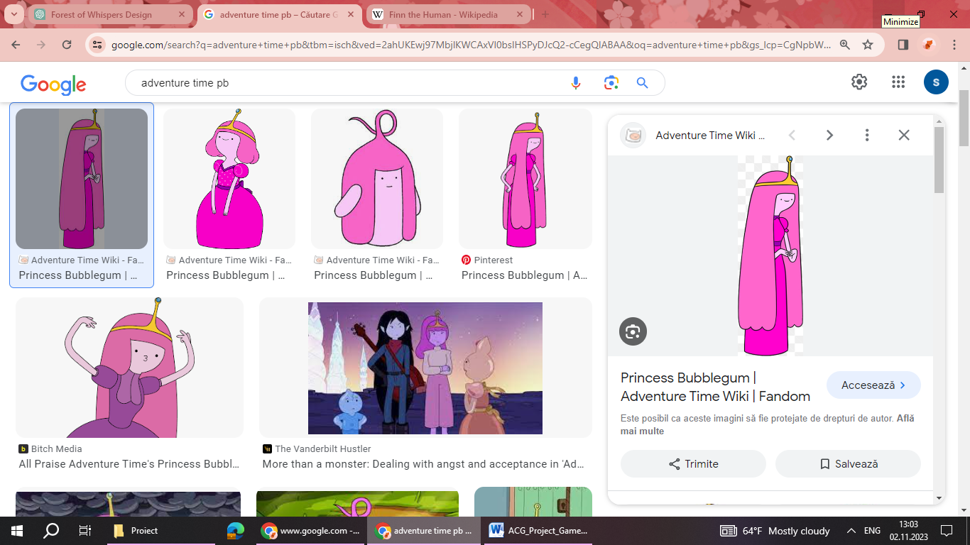

**Backstory**

Princess Bubblegum, also known as PB or Bonnibel, is a highly intelligent and scientifically inclined ruler of the Candy Kingdom in the Land of Ooo. She was originally created in a laboratory by her creator, Neddy, as a sentient piece of bubblegum. Over time, she evolved into a complex and resourceful princess with a deep sense of responsibility for her kingdom.

**Personality**

Princess Bubblegum is characterized by her intelligence, pragmatism, and dedication to her people. She is a natural leader, often displaying a no-nonsense approach when it comes to ruling her kingdom. Despite her serious demeanor, Princess Bubblegum cares deeply for her subjects and is shown to have a softer side, especially when it comes to her friends.

**Appearance**

Princess Bubblegum has pink skin and long, flowing pink hair. She typically wears a poofy pink dress and a crown adorned with a gem. Her appearance reflects her regal status and the candy-themed nature of her kingdom.

**Animations**

Lab Work: Princess Bubblegum is often shown conducting experiments or working in her lab, which involves precise movements and scientific equipment.

Leadership Gestures: Her animations convey authority and confidence, reflecting her role as a ruler.

Expressive Facial Reactions: Princess Bubblegum's facial expressions range from stern and focused to warm and caring, reflecting her emotional depth.

**Abilities**

Genius-level Intellect: Princess Bubblegum is a brilliant scientist and inventor, capable of creating advanced technology and conducting complex experiments.

Gum Manipulation: She can manipulate and transform her own body made of bubblegum, allowing her to shape-shift, stretch, and create various constructs.

Alchemy and Chemistry: She has a deep understanding of alchemy and chemistry, allowing her to create powerful potions and concoctions.

Leadership Skills: As the ruler of the Candy Kingdom, Princess Bubblegum is a skilled leader, capable of making tough decisions for the well-being of her subjects.

**Relevance to the Story**

Princess Bubblegum's role in Adventure Time is central to the overall narrative. Her responsibilities as a ruler often lead to conflicts, challenges, and quests that contribute to the richness of the storyline. Her scientific expertise and technological advancements play a crucial role in the Land of Ooo's survival.

**Relationship to Other Characters**

Finn the Human: Princess Bubblegum shares a complex relationship with Finn. While Finn has a longstanding crush on her, their dynamic evolves over time. They develop a deep mutual respect and friendship, with Princess Bubblegum recognizing Finn's bravery and determination.

Jake the Dog: Princess Bubblegum and Jake have a respectful and amicable relationship. Jake often supports Finn's interactions with her and appreciates her intelligence and leadership.

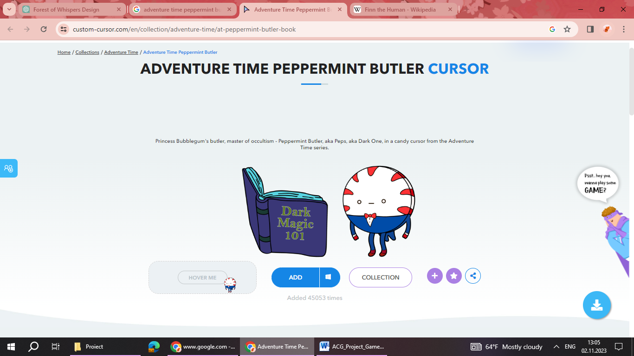

**Backstory**

Peppermint Butler, often referred to simply as Peppermint, is a loyal and enigmatic character in Adventure Time. Not much is known about his origins, but he serves as Princess Bubblegum's trusted butler in the Candy Kingdom. However, it's hinted that Peppermint Butler has a darker side, with connections to the occult and an understanding of arcane arts.

**Personality**

Peppermint Butler is characterized by his reserved and formal demeanor. He is typically polite and dutiful in his role as a butler. However, he also possesses a mysterious and potentially sinister side, as hinted by his knowledge of dark magic and occult practices.

**Appearance**

Peppermint Butler is a small, humanoid candy creature with a red and white striped appearance, resembling a peppermint candy. He wears a black tuxedo and has a monocle, emphasizing his butler-like appearance.

**Animations**

Butler's Grace: Peppermint Butler's movements are precise and graceful, befitting his role as a butler. He moves with a sense of elegance and poise.

Occult Gestures: When engaged in magic or occult practices, Peppermint Butler's animations may include intricate hand movements and incantations.

**Abilities**

Occult Knowledge: Peppermint Butler has a deep understanding of dark magic and the occult. He is capable of performing rituals and casting spells, which can range from summoning creatures to creating magical artifacts.

Summoning: He has the ability to summon various creatures and beings, often to assist in tasks or challenges.

Alchemy: Peppermint Butler is skilled in alchemical practices, allowing him to create potions and elixirs with various effects.

**Relevance to the Story**

Peppermint Butler's mysterious nature and knowledge of the occult occasionally lead to his involvement in darker and more supernatural storylines within Adventure Time. While he typically remains in the background, his abilities and connections to the mystical add an intriguing layer to the overall narrative.

**Relationship to Other Characters**

Princess Bubblegum: Peppermint Butler serves as Princess Bubblegum's loyal butler and assistant. While their interactions are professional, it's implied that there's a deeper level of trust between them, particularly in matters related to the arcane.

Finn and Jake: Peppermint Butler has occasional interactions with Finn and Jake, often seeking their assistance in matters involving the supernatural. They share a mutual respect for each other's abilities.

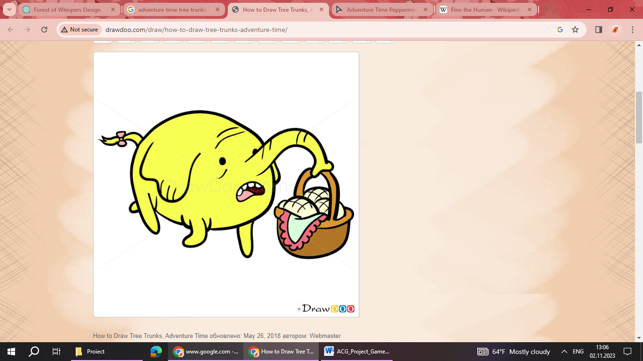

**Backstory**

Tree Trunks is a cheerful and kind-hearted elderly elephant who resides in the Land of Ooo. Originally from a rural apple orchard, Tree Trunks ventured out to seek adventure and excitement. Along the way, she met Finn and Jake, and the three of them became fast friends.

**Personality**

Tree Trunks is known for her sweet and gentle nature. She exudes warmth and positivity, always seeing the best in people and situations. Despite her age, she maintains a youthful enthusiasm for life and is unafraid to embark on new adventures. She has a penchant for baking delicious apple pies, which she takes great pride in.

**Appearance**

Tree Trunks is a small, anthropomorphic elephant with large, expressive eyes and a tuft of white hair on her head. She often wears a blue dress, which complements her friendly and approachable demeanor.

**Animations**

Deliberate Movements: Due to her age, Tree Trunks' movements are slow and deliberate, reflecting her careful nature.

Cooking and Baking: Her animations often involve preparing and baking apple pies, showcasing her culinary skills.

Hugs and Affectionate Gestures: Tree Trunks is known for her affectionate nature and often engages in hugs or embraces with her friends.

**Abilities**

Cooking and Baking: Tree Trunks is an exceptional baker, particularly known for her apple pies. Her pies are renowned for their deliciousness and are sought after by many in the Land of Ooo.

Wisdom and Life Experience: Despite her age, Tree Trunks possesses a wealth of life experience and wisdom. She often imparts valuable advice to Finn and Jake.

**Relevance to the Story**

Tree Trunks plays a recurring role in Adventure Time, often appearing in episodes where her baking skills or wisdom become essential to the plot. Her presence adds a touch of warmth and homeliness to the show, and her friendship with Finn and Jake is a testament to the diverse range of characters in the Land of Ooo.

**Relationship to Other Characters**

Finn and Jake: Tree Trunks shares a close and affectionate friendship with Finn and Jake. They look out for her and often go on adventures together. They have a deep respect for her wisdom and value her as a trusted companion.

Princess Bubblegum: Tree Trunks has a friendly relationship with Princess Bubblegum. They share a mutual respect, and Princess Bubblegum has been known to seek out Tree Trunks' advice on occasion.

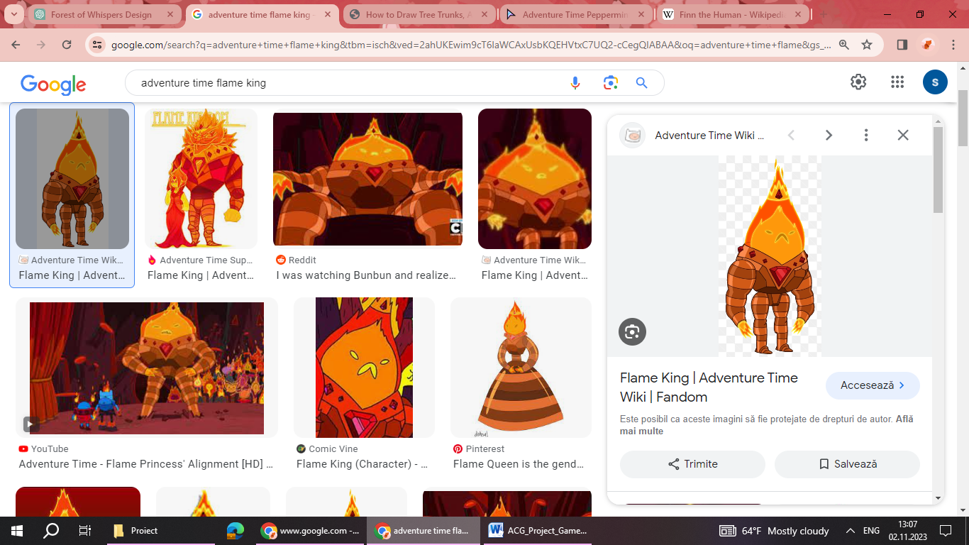

**Backstory**

The Flame King, also known as Furnius, is a powerful fire elemental and the ruler of the Fire Kingdom in Adventure Time. He is the biological father of Flame Princess. The Flame King's rule is marked by a strict and authoritarian approach, with a focus on maintaining control over the Fire Kingdom.

**Personality**

The Flame King is characterized by his authoritative and domineering personality. He is stern, no-nonsense, and values order and obedience above all else. He is often portrayed as cold and calculating, prioritizing his own interests and power over the well-being of his subjects.

**Appearance**

The Flame King has a fiery, humanoid appearance, with flames emanating from his body. He wears a crown adorned with a large red gem, signifying his royal status. His eyes glow with an intense, fiery light, reflecting his elemental nature.

**Animations**

Fire Manipulation: The Flame King's animations involve the controlled manipulation of flames, showcasing his mastery over fire.

Authoritative Gestures: His movements convey authority and power, reflecting his position as ruler.

Intimidating Presence: The Flame King's demeanor and body language exude a sense of menace and power.

**Abilities**

Pyrokinesis: The Flame King possesses the ability to control and generate fire, making him an extremely formidable adversary.

Heat Immunity: As a fire elemental, he is immune to extreme heat and fire-related attacks.

Leadership Skills: The Flame King is an effective and authoritarian leader, using his strategic prowess to maintain control over the Fire Kingdom.

**Relevance to the Story**

The Flame King's rule and his relationship with Flame Princess play a significant role in the Adventure Time narrative. His actions and decisions impact the political dynamics of the Fire Kingdom and influence Flame Princess's character arc.

**Relationship to Other Characters**

Flame Princess: The Flame King is Flame Princess's biological father. Their relationship is complex, marked by a strained dynamic due to the Flame King's oppressive rule and Flame Princess's desire for independence.

Finn and Jake: Finn and Jake have encountered the Flame King in their adventures, often in relation to Flame Princess. They view him as an antagonist due to his oppressive rule and his mistreatment of Flame Princess.

Princess Bubblegum: Princess Bubblegum, as a fellow ruler, may have interactions with the Flame King in matters related to diplomacy or conflicts that involve the Fire Kingdom.

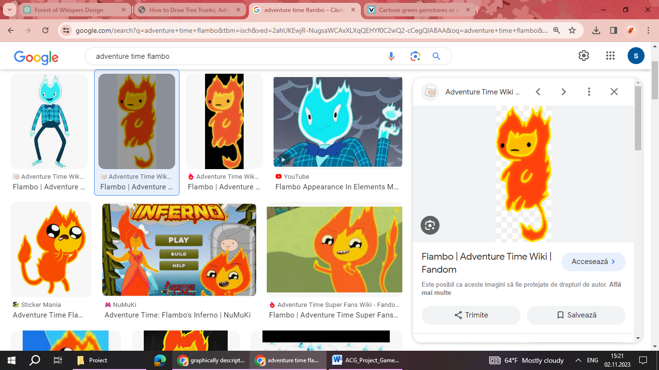

**Backstory**

Flambo is a fire elemental in Adventure Time known for his fiery personality and connection to the Fire Kingdom. He is a recurring character known for his mastery over flames and his role as a guide and intermediary between other characters and the fiery realm.

**Personality**

Flambo is energetic, spirited, and exuberant. He exudes confidence and has a mischievous streak, often displaying a playful and lively demeanour. Despite his fiery nature, he is generally good-natured and enjoys socializing with others.

**Appearance**

Flambo is a humanoid fire elemental, with flames constantly flickering from his body. He has a tall, slender build, with expressive eyes and a fiery mane of hair. He typically wears a pair of pants, reflecting a casual and carefree style.

**Animations**

Flames Dance: Flambo's animations involve the constant movement and flickering of flames around his body, emphasizing his elemental nature.

Energetic Movements: He moves with agility and enthusiasm, reflecting his lively personality.

Fire Manipulation: Flambo demonstrates his control over fire through various gestures and motions.

**Abilities**

Pyrokinesis: Flambo has the ability to control and manipulate fire, allowing him to create and shape flames for various purposes.

Heat Immunity: Due to his elemental nature, Flambo is immune to extreme heat and fire-related damage.

Fire Magic: He is skilled in fire-based magic, allowing him to conjure powerful spells and create intricate fire patterns.

**Relevance to the Story**

Flambo serves as a recurring character with ties to the Fire Kingdom. He often acts as a guide, providing information or assistance to other characters seeking to navigate the fiery realm. His expertise in fire-related matters makes him a valuable asset in situations involving flames.

**Relationship to Other Characters**

Finn and Jake: Finn and Jake have encountered Flambo on multiple occasions. They share a friendly and amicable relationship, with Flambo often providing them with advice or assistance related to fire-based challenges.

Princess Bubblegum: Flambo may have occasional interactions with Princess Bubblegum, particularly in scenarios where his knowledge of fire-related matters proves beneficial.

Flame Princess: As a fire elemental like Flambo, Flame Princess shares a natural affinity with him. While they may not have extensive interactions in the story, they share a common elemental bond.

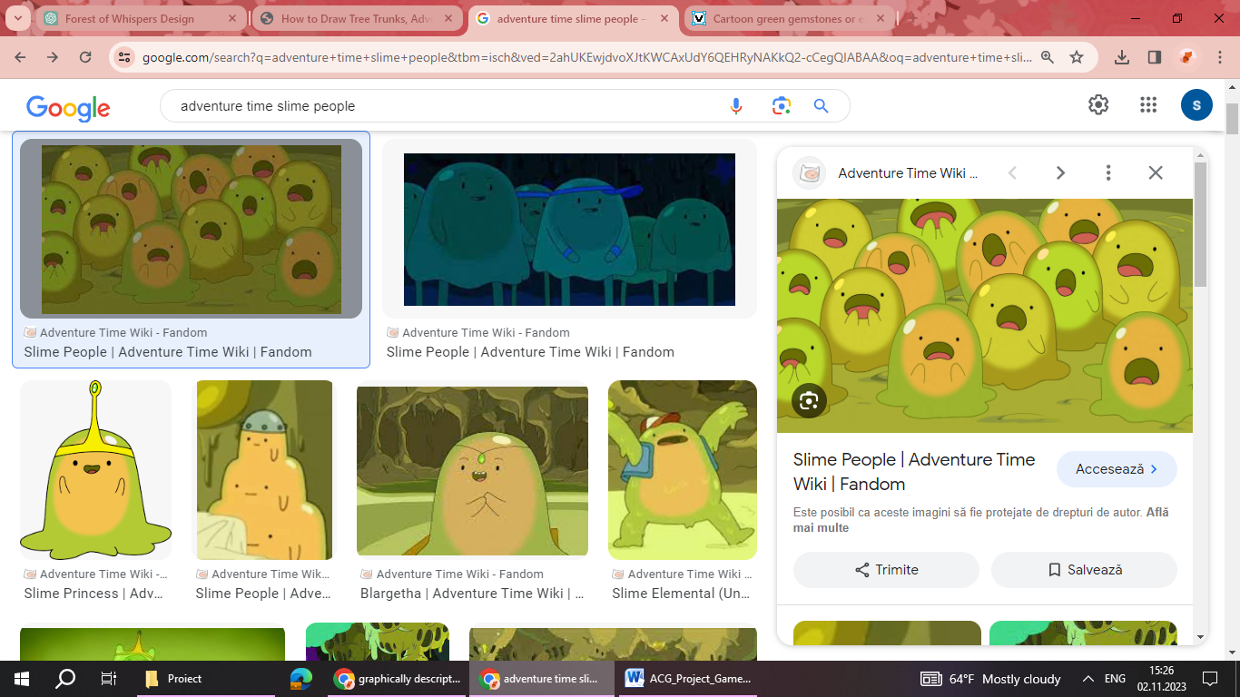

**Backstory**

Slime Subject is an inhabitant of the Slime Kingdom in Adventure Time. It is an amorphous, gelatinous creature with a variety of form and size. Slime Subject is known for their playful and whimsical nature, often engaging in activities that involve its gooey composition.

**Personality**

Slime Subject is generally carefree, jovial, and light-hearted. It has a playful and childlike demeanour, often displaying a sense of curiosity and wonder about the world around. It is known for its friendly and welcoming attitude towards others.

**Appearance**

Slime Subject comes in a range of shape, size, and color, reflecting the diversity of the Slime Kingdom. It’s an amorphous, gel-like creatures with a translucent and gooey appearance. Some may have simple facial features, while others may be more complex in design.

**Animations**

Bouncing and Morphing: Slime Subject is constantly in motion, often bouncing or morphing into different shapes as it moves.

Playful Gestures: Its movements is characterized by playful gestures, showcasing its cheerful and animated nature.

Stretching and Squeezing: Due to its gelatinous composition, it can stretch, squeeze, and reshape itself in various ways.

**Abilities**

Amorphous Form: Slime Subjects has the ability to change its shape and size, allowing to adapt to different environments and situations.

Slime Manipulation: It can produce and manipulate slime, which can be used for various purposes, such as creating objects or even trapping adversaries.

Regeneration: Slime Subjects has the ability to regenerate from injuries, making them resilient and durable.

**Relevance to the Story**

Slime Subjects play a minor but charming role in Adventure Time, often appearing in the story related to the Slime Kingdom.

**Relationship to Other Characters**

Finn and Jake: Finn and Jake may encounter Slime Subject in their adventures, particularly when exploring different regions of the Land of Ooo and helping with possible tasks

Slime princess: Slime Subject has a deep respect and affection for Princess Slime, its benevolent and caring leader. It looks to her for guidance and protection, and she treats it with kindness and consideration.

1. **Interface**
   1. Audio, Music, Sound Effects Audio

Background music changes dynamically based on the game environment (e.g., intense music during combat).

Sound Effects: Footsteps, environmental sounds, and character voiceovers during key events.

1. **Artificial intelligence**
   1. Opponent and enemy AI

**2D prototype**

The enemy has a fixed number of lives. At any point, if it has more than half of its starting health, the enemy will move towards the player, trying to attack him. When the enemy takes damage, he gets knocked back. If its health is smaller than half of its starting health, the enemy cannot move anymore, and he can just receive damage until he dies.

* 1. Non-combat and Friendly Characters

All the friendly characters in the game are static. To interact with a static character, the player needs to be in the proximity and to press the interaction key.

1. **Hardware**
   1. Target Hardware Platform

Designed for Windows PC

* 1. Development Hardware and Software

Hardware: Development on PCs.

Software: OpenGl.

**8. Game art**

A cartoonish art style that features exaggerated and stylized visuals, drawing inspiration from the tv series that the game is based on.

The art style will use bright and bold color palettes to enhance the visual appeal and create a lively atmosphere. Colors are often saturated to add energy and excitement. Characters and environments are simplified into basic shapes, making them easily recognizable and distinctive. This simplicity contributes to a clean and approachable aesthetic. The textures can be simple and stylized, contributing to the overall artistic theme.